**Analysis and Visualization of Biological Networks with Cytoscape**

John “Scooter” Morris, Ph.D., UCSF (scooter@cgl.ucsf.edu)

Allan Kuchinsky, Agilent (allan_kuchinsky@agilent.com)

Alex Pico, Ph.D., Gladstone Institutes (apico@gladstone.ucsf.edu)

Table of Contents

Overview 3

Introductions and setup 8

Introductions 8

Notes 8

Setup 9

Biological Networks 10

The Challenge 10

Biological Network Taxonomy 12

Pathways 12

Interactions 13

Similarity 14

Analytical Approaches 15

Organization of complex networks 15

Concepts 16

Scale-free networks 17

Small-world networks 18

Random networks 19

Network measures 20

Guilt by association 26

Network motifs 27

Overrepresentation analysis 28

Visualization 29

Depiction 29

Data Mapping 29

Layouts 31

Animation 33

Introduction to Cytoscape 34

Core Concepts 34

Visual Styles 35

Apps 37

BiNGO 37

Agilent Literature Search 39

Loading Networks 40

Loading Networks from a Web Service 40

Load a Network from a Table 42

Load Tables 45

Tips and Tricks 48

The ‘”Root Graph” 48

Network Views 48

Sessions 49

Task Monitor 49

Memory 49

Final points on Tips and Tricks 50

Demo/Sample use cases 51

Use case 1: Expression data analysis 51

Use case 2: Protein complexes in protein-protein interaction networks 55

Hands-on tutorial: Introduction to Cytoscape 58

Hands-on tutorial: Working with data 59

Hands-on tutorial: Analysis of microarray data 60

Bibliography 61

# Overview

Networks have long been used to represent important biological processes. Many of us remember memorizing the Krebs (TCA) cycle, which is usually shown as a directed graph, itself a type of network (Figure 1). Recently, however, the use of networks in biology has changed from purely illustrative and didactic to more analytic, even including hypothesis formulation. This shift has resulted, in part, from the confluence of advances in computation, informatics, and high-throughput techniques in systems biology. Today the analysis and visualization of biologically relevant networks has become commonplace, whether the networks represent metabolic, regulatory, or signaling pathways; protein-protein or genetic interactions; or more abstract connections between similar proteins or similar ligands. Networks are now routinely used to show relationships between biologically relevant molecules, and analysis of those networks is proving valuable for helping us understand those relationships and formulate hypotheses about biological function.

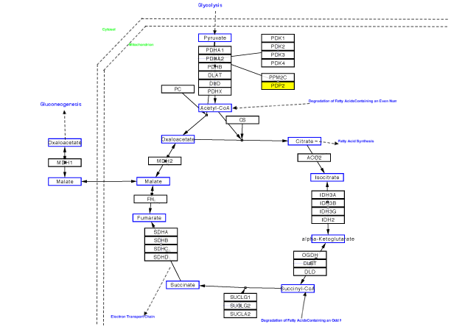

Figure . The TCA cycle from WikiPathways

**Figure 1**. The TCA cycle from wikipathways (http://www.wikipathways.org)

With the advent of high-throughput methods that generate vast amounts of data from diverse measurement sources – for example gene expression data from microarrays, protein or metabolite abundance from mass spectrometry – biological networks have become increasingly important as an integrating context for data. As a commonly understood diagrammatic representation for concepts and relationships, networks provide structure that helps reduce underlying complexity of the data. Network tools give us functionality for studying complex processes. We can analyze global characteristics of the data, via metrics such as degree, clustering coefficient, shortest paths, centrality, density. We can identify key elements (hubs) and ‘interesting’ subnets, which can help us to elucidate mechanisms of interaction. Also, visualization of data superimposed upon the network can help us understand how a process is modulated or attenuated by a stimulus.

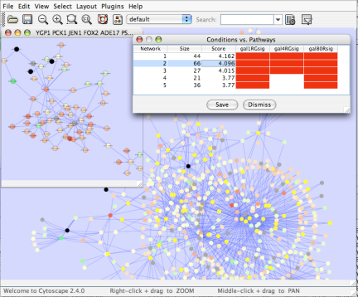Network tools have proven to be extremely useful in analyzing and visualizing important biological processes. Some general applications of networks in biology include:

* **Gene Function Prediction** – Examining genes (proteins) in a network context shows connections to sets of genes/proteins involved in same biological process that are likely to function in that process [1-4].

Figure . Gene Function Prediction using jActiveModules

* 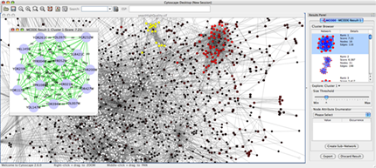**Detection of protein complexes/other modular structures** – although interaction networks are based on pair-wise interactions, there is clear evidence for modularity & higher order organization (motifs, feedback loops) [5-9]

Figure . Identifying molecular complexes in large protein interaction networks using MCODE

* 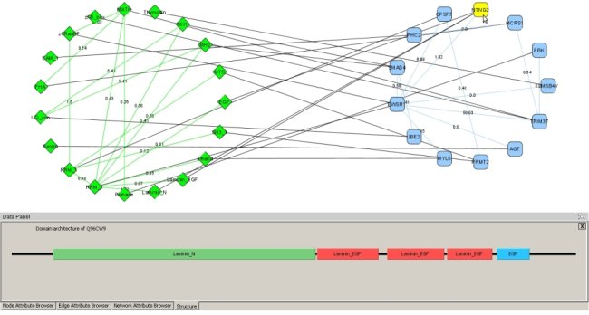**Prediction of new interactions and functional associations** – There are several methods for predicting interactions and functional associations, based upon network structure and correlations amongst data. For example, orthology-based methods have been used to predict interactions for a species based upon orthology to interacting pairs of proteins in evolutionarily similar organisms[10]. Other researchers have used Bayesian network approaches to inferring gene regulatory networks from time course gene expression data[11]. In another approach, shown on the example below, statistically significant domain-domain correlations in protein interaction network suggest that certain domain (and domain pairs) mediate protein binding. Machine learning extends this to predict protein-protein or genetic interaction through integration of diverse types of evidence for interaction [12-14].

Figure . Visualizing domain interactions and alternative splicing using DomainGraph

Moreover, these same tools and their associated analysis and visualization methods can provide key insights in the study of disease and in drug development. These include:

* 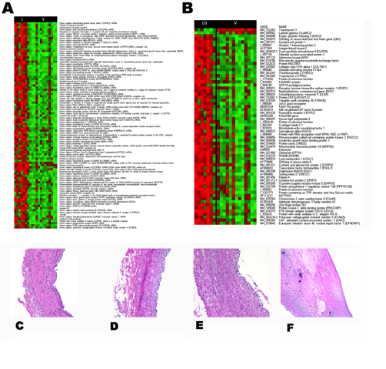**Identification of disease subnetworks** – identification of disease network subnetworks that are transcriptionally active in disease. These suggest key pathway components in disease progression and provide leads for further study and potential therapeutic targets [15-20].

Figure 5. Gene expression profiles and American Heart Association (AHA) histological classification of atherosclerotic lesions (left panel). Differentiation scores were calculated for all genes across pairwise conditions (e.g. diabetic vs. non-diabetic patients). A large literature network was built for atherosclerosis. Connectivity analysis was used to extract a transcriptionally-active subnetwork for diabetic vs. non-diabetic conditions (right panel).

* 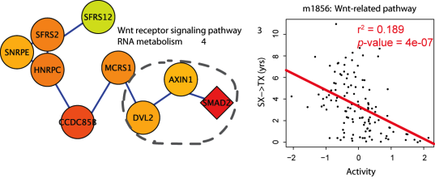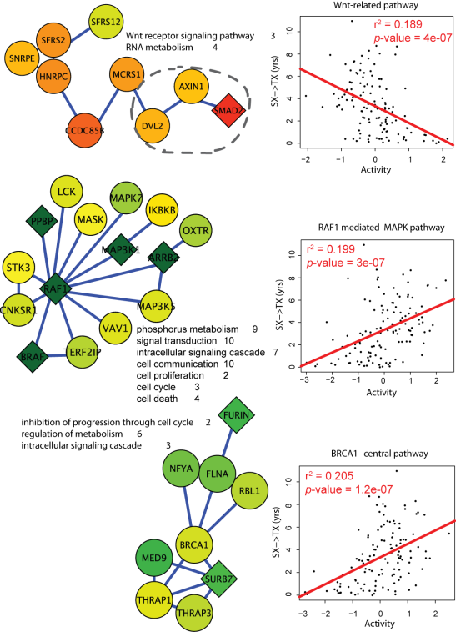**Subnetwork-based diagnosis** – subnetworks also provide a rich source of biomarkers for disease classification, based on mRNA profiling integrated with protein networks to identify subnetwork biomarkers (interconnected genes whose aggregate expression levels are predictive of disease state[21, 22]).

Figure 6. A network-based approach identified prognostic markers not as individual genes but as subnetworks extracted from molecular interaction databases. Gene expression profiles from Chronic Lymphocytoic Leukemia patients were mapped to a large human molecular interaction network. A search over this network was performed to identify prognostic subnetworks that could be used to predict treatment-free survival.

* 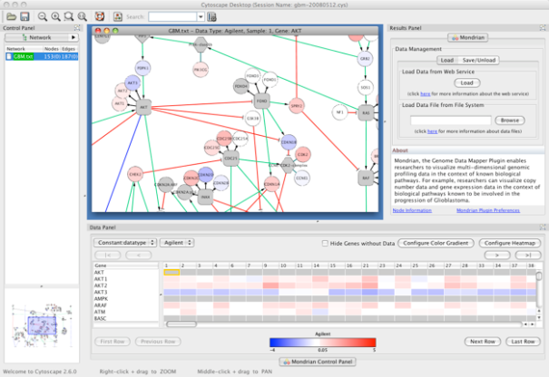**Subnetwork-based gene association** – molecular networks will provide a powerful framework for mapping common pathway mechanisms affected by collection of genotypes[23, 24].

Figure 7. Cytoscape Mondrian plugin with a dataset derived from the TCGA Glioblastoma Pilot Project. This dataset contains mutations, copy-number alterations, and expression data for 91 samples.

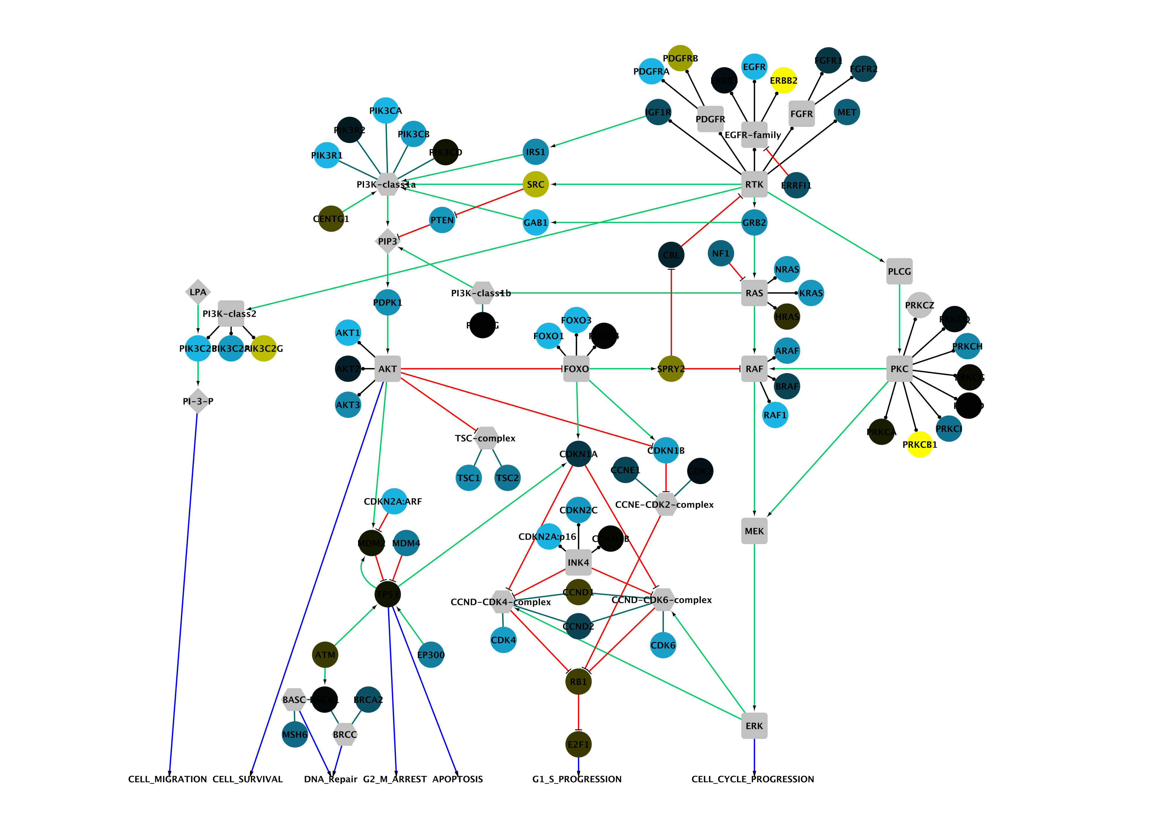

Figure 8. Partial pathway showing genes implicated in glioblastoma multiforme colored by the changes in copy number

**Figure 2**. Partial pathway showing genes implicated in glioblastoma multiforme colored by the changes in copy number variation detected in one patient’s tumor.

For the purposes of this tutorial, we will classify biological networks into three major categories: pathways, similarity networks, and interaction networks. Pathways include metabolic, regulatory, and signaling networks. Figure 2 shows a pathway containing genes involved in glioblastoma multiforme, a major form of brain cancer [25]. These genes were identified by a large-scale genetic analysis of copy number variation and genetic changes in 206 glioblastoma multiforme patients. The study was conducted as part of The Cancer Genome Atlas (TCGA) project. Notably, the study demonstrated that there was no single genetic defect responsible for glioblastoma multiforme, but that all of the cases showed significant pathway changes – strongly suggesting that this form of cancer is a “pathway disease.” From a visualization standpoint, the real power is the ability to map expression, mutation, or copy number variation data onto pathways to reveal (or suggest) how the pathway and its components function under different sets of conditions, including disease states. Thus, the ability to analyze a variety of data sources and types and to map that data onto pathways is crucial. There are also techniques for deriving putative pathways from expression data[1] and for modeling the kinetics of biological processes [26] that are beyond the scope of this talk.

Interaction networks comprise the second category. In these networks, nodes represent biological entities and edges represent some form of interaction or relationship. A common example of this type is a protein-protein interaction (PPI) network. Figure 3 shows a yeast protein-protein interaction network generated by tandem affinity purification followed by mass spectrometry (TAP/MS) [27]. Analogous networks have been generated based on ligand similarities [28], protein similarities [29], and drug-target networks [30]. Generally, this class of biological networks can present as a “hair ball”, where there is so much information that the meaningful relationships are difficult to discern. There is good evidence that analysis of a PPI network to find highly connected “hubs” can be used to predict protein complexes [8], and clustering of protein similarity networks can provide clues to protein family (and hence functional) assignments (Figure 4).

**collins**

Figure 9. Partial protein-protein interaction network for *Saccharomyses cerevisiea* colored by predicted complexes.

**Figure 3**. Partial protein-protein interaction network for *Saccharomyses cerevisiea* colored by predicted complexes.

A variety of analytical techniques can help to elucidate interaction networks. Clustering methods such as MCL [31] have proven valuable, although several algorithms more specific to various types of interaction networks have also been developed (c.f.[5]. In addition to clustering, a variety of metrics can be applied to an interaction network or nodes within the network. The average density (node degree) of the network, average shortest-path distance, number of connected components, measures of centrality, and the extent to which the network fits a scale-free model are all useful descriptors for the analysis of an interaction network. Altering the layout and visual attributes of the network can also be helpful.

ah1

Figure 10. Protein similarity network of the amidohydrolase enzyme superfamily colored by subgroup.

Cytoscape is an open-source application for the visualization and analysis of (biological) networks. During my talk, I will use Cytoscape to demonstrate some of the techniques for visualizing and analyzing biological networks. In addition, I will demonstrate some ways that biological networks can be combined with other data to help elucidate function or the possible implications of changes in biological function due to perturbation, mutation, or infection.

# Introductions and setup

## Introductions

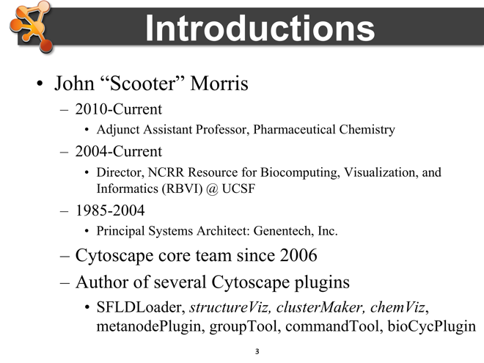The three instructors that initiated this tutorial are experienced Cytoscape developers, with a cumulative of 15 years of participation in the Cytoscape core team. All three have a strong background in Cytoscape development, both from the perspective of core development, but also from the perspective of developing plugins that extend Cytoscape functionality. They also have a long history of working in the biomedical field, both from the perspective of tool developers and the underlying science.

# Notes

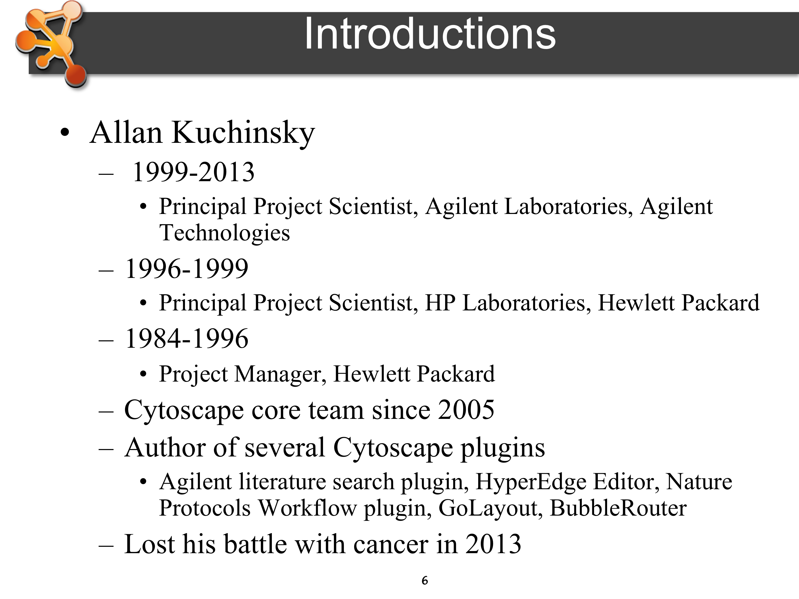

## Setup

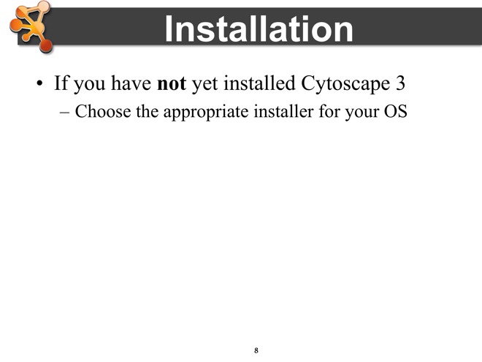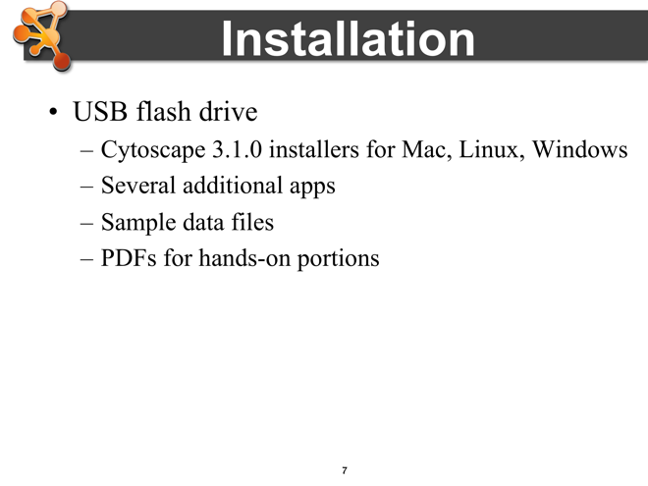For the purposes of this tutorial, we will be using Cytoscape 3.4. 3.x is the whole new version of Cytoscape with modular architecture. It is designed for long-term maintainability and eventually it replaces 2.x series. New major features, including new user interfaces, headless (command-line) distribution, and multiple rendering engine support, will be released for this version. Cytoscape 3.4 is available as installers for Mac, Windows, and Linux, which include the core and sample files. Apps are generally available for download with Cytoscape’s App Manager or from the App Store at http://apps.cytoscape.org/.

To avoid potential network problems or contention, we have provided all of the plugins that we will use for today on the CD that we’ve distributed.

**Notes**

# Biological Networks

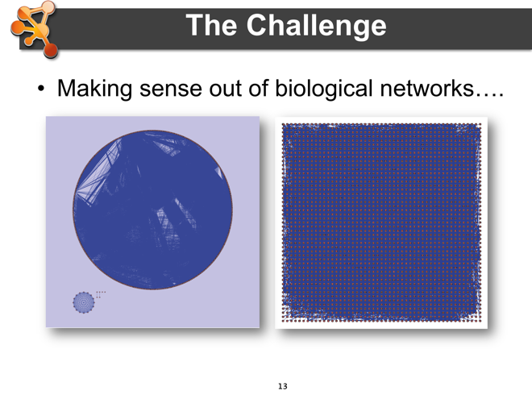In this section, we will begin to explore the use of networks in biology. We begin by posing a challenge: how do we make sense of biological networks? We pose that challenge by providing a series of pictorial examples of networks in biology.

## The Challenge

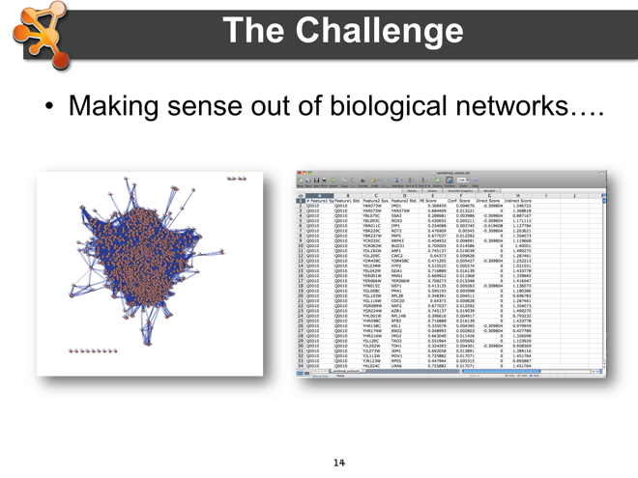The images on this slide are all representations of biological networks. The challenge we are faced with is to extract the “meaning” behind these representations, which may be a purely visual challenge, but it might also involve analytical approaches.

All of the images at the right represent biological networks, including the Excel spreadsheet. Without more information about the content, these images don’t tell us much. How can we extract this meaning? What are the analytical techniques? What are the common visualization approaches?

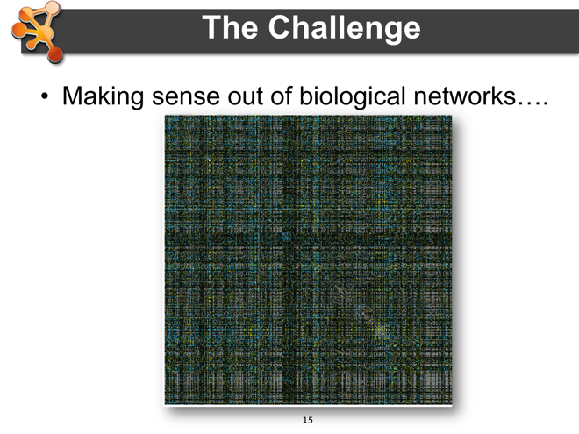**Notes**

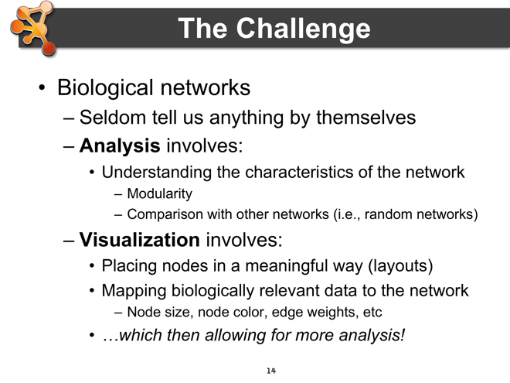

If we simply think of a biological network as a list of nodes and the edges that connect them, we’re not going to be able to gain much information. However, if we add information to those nodes and edges to that we can analyze the interactions (or similarities) in more depth, or we use that additional information to visualize the nodes in some meaningful manner, we will find it easier to gain (or communicate) insight about aspects of the network. There are a number of analytical and visualization approaches that can help us, which are described below.

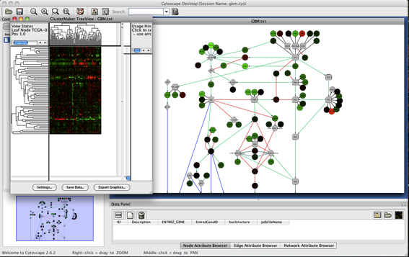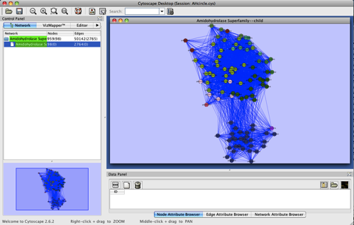Taking the networks that we showed before, we can begin to analyze or visualize additional data. In the image at the right, we’ve colored the nodes in the network by protein family membership (members of protein families share functional characteristics), and then performed an edge-weighted layout where the edge weights represent the BLAST similarity between the proteins. As you can see pretty quickly that similar proteins tend to group together.

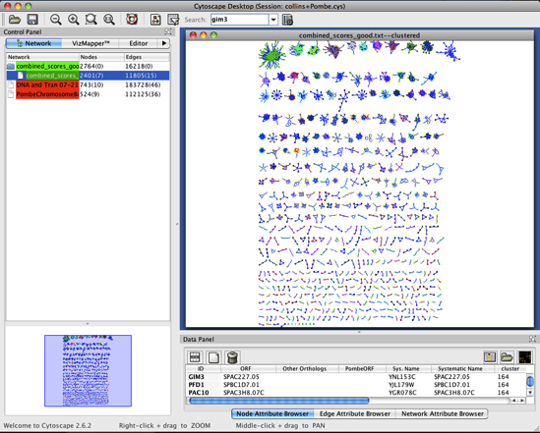In this example, we’ve combined a network representation with an analysis of some of the associated data. The image at the left is a hierarchical clustering of all of the genes in the TCGA glioblastoma study vs. all of the patients in the study. This allows us to look for patterns in the heat map and associate those patterns with specific genes or groups of genes in the pathway.

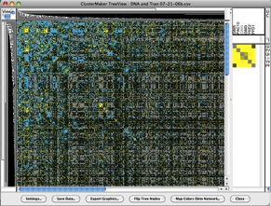In the final example on the right, we have combined two different visualizations with two different analyses. The heat map on the left represents a hierarchical cluster of genetic interactions and the network shows the results of an MCL cluster of a set of physical interactions. These views are linked, allowing users to select groups in one view and determine if the same groups exist in the other view. This allows researchers to explore areas where there are tight protein-protein physical interactions as well as genetic interactions, providing pretty strong evidence for the existence of a complex.

But, how do we know what kinds of analyses make sense, and what kinds of visualizations are appropriate?

## Biological Network Taxonomy

Before tackling this question, we need to understand that not all “biological networks” are the same. In particular, there is a sort of taxonomy of networks – each visualization or analytical technique can be either more or less appropriate for the different network types. For our purposes, we can divide these biological networks into 3 main groups: pathways, interaction networks, and similarity networks.

### Pathways

The first type of network in our taxonomy is probably the most familiar. We’ve all seen pathway diagrams, whether those pathways represent signaling pathways, metabolic pathways, or regulatory pathways. These networks are often hand-curated diagrams that have been constructed for didactic purposes. However, even though the positions and graphical annotations associated with these networks does not lend them to the normal types of network analysis techniques, they can be extremely useful as templates on which we can paint expression profile information, or any other kinds of annotation that we want to use to show information associated with the curated pathway. Phylogenetic trees can also be thought of in a similar fashion of those trees have been hand curated like the kinase phylogenetic tree [32] shown in the slide.

**Notes**

### Interactions

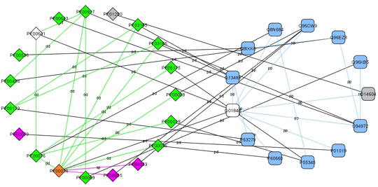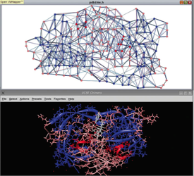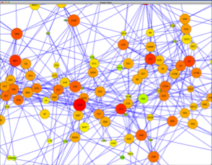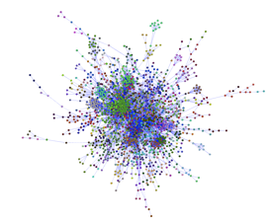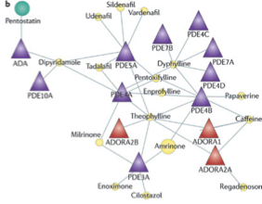The second type of networks in our taxonomy are interaction networks. While pathways are probably familiar to most because of their use for educational purposes, interaction networks are what most people of when we think of “network biology”. Basically, these networks reflect the interactions between biological entities. The entities might all be proteins, giving us the canonical protein-protein interaction network shown to the right in the first frame. The interacting entities also be genes, in which case, the network could be a genetic interaction network. The middle panel at the right shows a particular representation of an epistatic miniarray profile (EMAP). These networks are formed by recording the differential results of double-delete mutants when compared to the expected combination of single-delete mutants. The last network shows a protein-ligand interaction network. Interaction networks don’t necessarily need to have only one interacting entity, and as we are rediscovering the importance of metabolic pathways, the “metabolome”, which combines metabolites with the enzymes and regulatory proteins which control metabolism. There are also efforts underway to understand how the interactomes of pathogens interact with the interactomes of their hosts – yet another kind of “mixed” interaction network.

Of course, there are many kinds of biological interactions we might be interested in, up to and including how people interact with each other. Such social networks are beyond our scope, but social network analysis is very similar to biological networks analysis and provide a fruitful source of algorithms and visualization techniques.

**Notes**

### Similarity

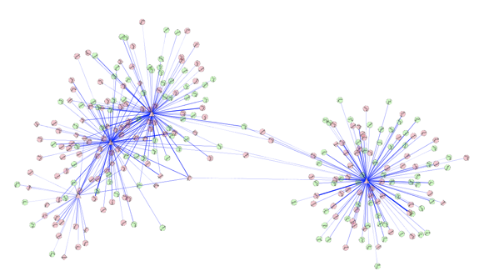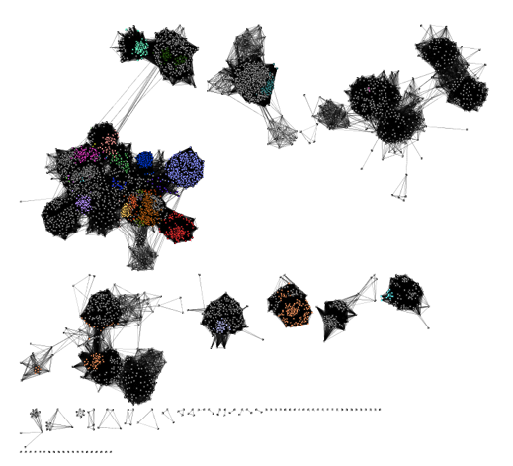The final type of networks we want to discuss are similarity networks. In similarity networks, the nodes represent biological entities and the edges represent some measure of the similarity between them. There are several types of similarity networks that are commonly used in biology today. One common similarity metric is the Tanimoto coefficient[33-35], which represents the similarity between two small molecules based on the chemical fingerprints of each of them[36]. Other similarity metrics include sequence similarity as measured by BLAST[29, 37], PSI-BLAST[38], or Smith-Waterman[39], structural similarity as measured by RMSD or other structural similarity measures[40-45], or the ligand similarity as measure by the similarity ensemble approach (SEA) method[28].

There are other types of non-biological networks that use various kinds of similarity measures. Tag clouds[46] and topic maps[47], which is one of the semantic web technologies.

The images at the right show two examples of similarity networks. The network on top is a protein-protein similarity network showing the Amidohydrolase enzyme superfamily from the Structure-Function Linkage Database (SFLD)[48]. The colors on the network represent proteins of similar function. Note that these proteins tend to group together based on their BLAST similarity[29].

The network on the bottom shows a network of small-molecules where the edges represent the Tanimoto similarity between them. These networks can be useful to find molecules with similar structural characteristics

**Notes**

## Analytical Approaches

The analysis of networks is a large and complex topic that we can’t do justice in a single tutorial (even less a tutorial handout). In general, network analysis is part of the mathematics known as graph theory, and there are entire conferences (and many textbooks) devoted to the area. A good starting point might the Wikipedia article[49] or the online book “Graph Theory with Applications”[50]. Our goal here is to provide a brief introduction and touch on some of the main approaches used with biological networks.

### Organization of complex networks

Complex networks have different levels of organization. The illustrations on the right show how to breakdown the *hairball* that arises when we usually plot a large complex network. First, we can look at single nodes and their local properties as the *node degree*. These nodes are then linked to form *motifs*, small subnetworks of three or more nodes. Motifs are combined to form *communities* or *modules* and communities are joined into the entire network. The *hierarchy* of the network describes how the various structural elements are combined.

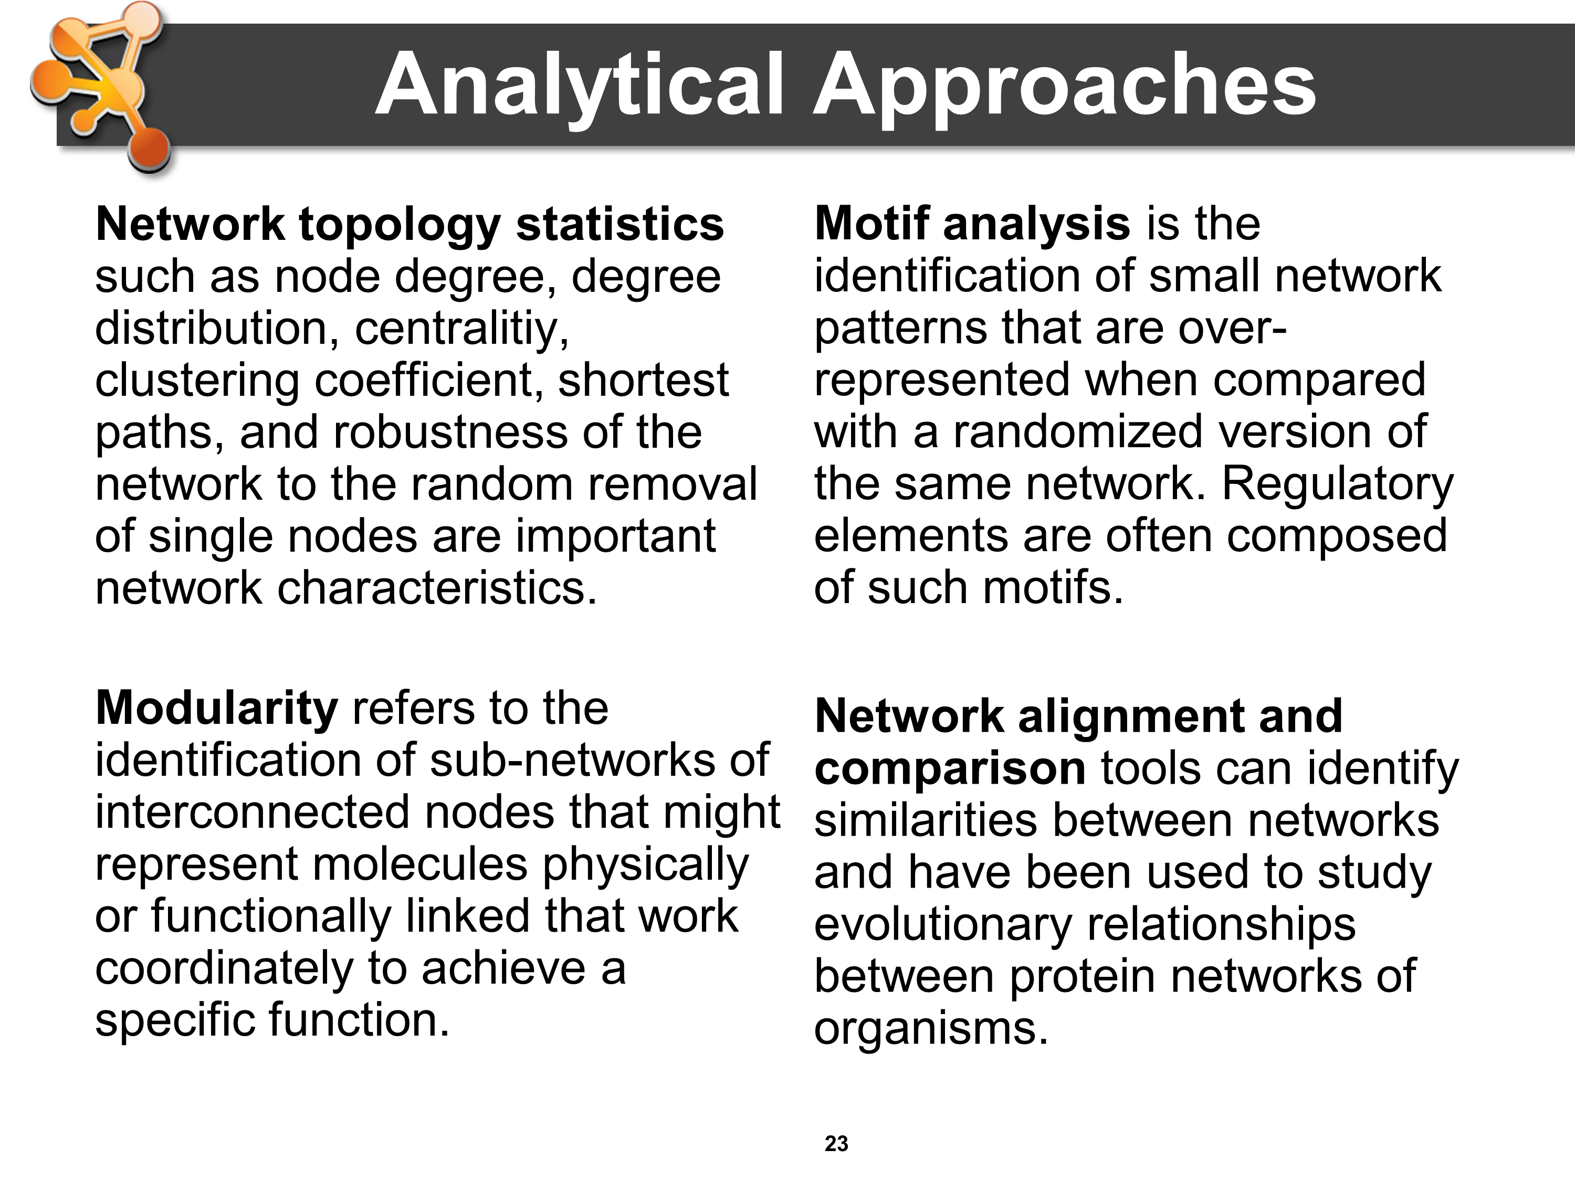There are some typical analysis tasks that are often performed with biological networks.

* Network topology statistics are easy to compute and to compare among different networks. Among others they include node centrality, betweenness, degree distribution of nodes, clustering coefficient, shortest path between nodes and robustness of the network to the random removal of single nodes.
* Modularity refers to the identification of sub-networks of interconnected nodes that might represent molecules physically or functionally linked that work coordinately to achieve a specific function.
* Motif analysis is the identification of small network patterns (or subgraphs) that are over-represented when compared with a randomized version of the same network. Discrete biological processes such as regulatory elements are often composed of such motifs.
* Network alignment and comparison tools can identify similarities between networks (such as common subgraphs) and have been used to study evolutionary relationships between protein networks of organisms.

### Concepts

In mathematical terms, a biological network (any network for that matter) is a graph, often written:

*G = (V(G), E(G), ψG)*

where *V(G)* are the set of vertices (nodes) in the graph and *E(G)* are the set of edges. In this particular notation, *ψG* is the set of incidence functions that define which edge goes with which vertices.

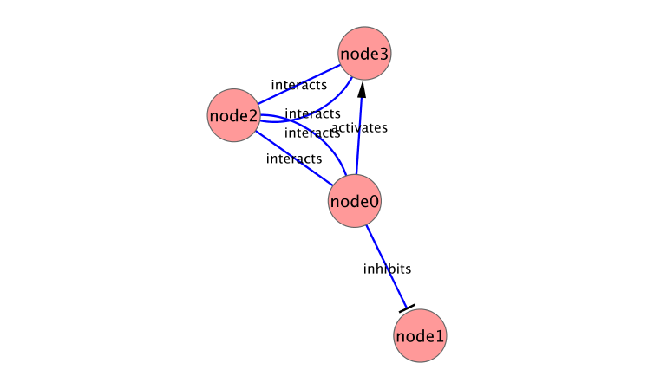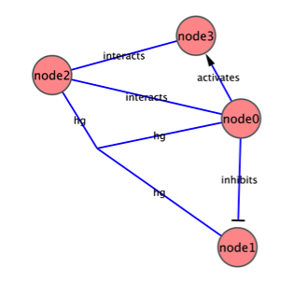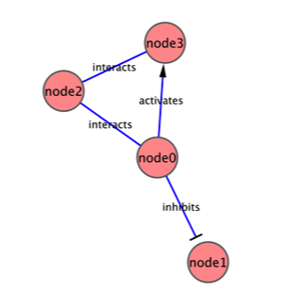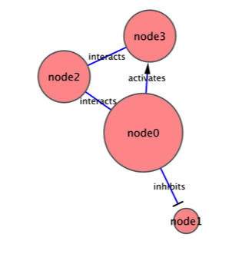The edges between nodes can either be directed or undirected. This is easiest to understand when considering the *degree* of a node. In an undirected network, the degree of a node is simply the number of edges connected to it. In the first simple network at the right, the node (**node0**) has three edges connected to it, so it has a degree of 3. In a network with directed edges, we need to expand our concept of degree to include *in-degree*, the number of edges that connect *to* this node, and *out-degree*, the number of edges that originate *from* this node. In the second network at the right, the size of the nodes reflects the node degree.

There are also differences between the types of networks. The first network at the right is a *multigraph*. In a multigraph, there can be multiple edges between nodes. The network at the far right on the other hand, is a *hypergraph*. In a hypergraph, an edge can be connected to more than two edges.

**Notes**

### Scale-free networks

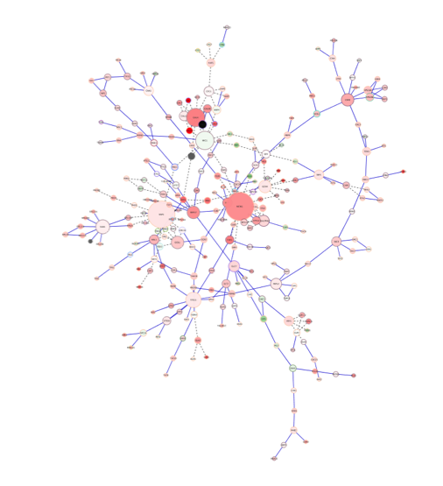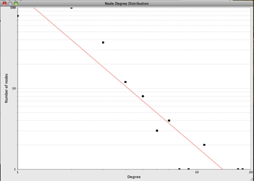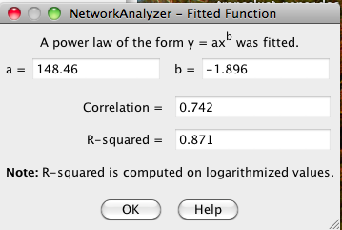One property of network topology that is of interest is the *degree distribution* – that is, the distribution of how many edges each node has (also referred to as the *connectivity distribution*)[51]. A network is said to be *scale-free* if the degree distribution fits a power law. It has been reported that many types of biological networks are scale free[52-62]. The characteristics of scale-free networks are that there is a short path from any node to another node (*small world property*), there are many nodes with few connections and a few nodes with many connections (*hubs*), and the hubs are enriched with essential/legal nodes (*centrality and lethality principal*)[52, 63]*.*

Scale-free networks have interesting properties for biological systems – in particular, they are robust to random breakdowns[64]. They are also (as the name implies) invariant to changes in scale. On the other hand, recent analysis of several data sources have begun to throw into question exactly how well many biological networks fit the scale-free power law distribution[63, 65-67]. So, while none of the authors have suggested that biological networks don’t exhibit some scale-free characteristics, they don’t fit the power-law degree distribution well enough to be considered scale-free.

It should also be noted that biological networks aren’t the only network type that tends to be scale-free. For example, both social networks and the Internet tend to be scale-free[68, 69]. In both cases the overall topology tends to be one with a few hubs of high degree and lots of lower-degree nodes.

**Notes**

### Small-world networks

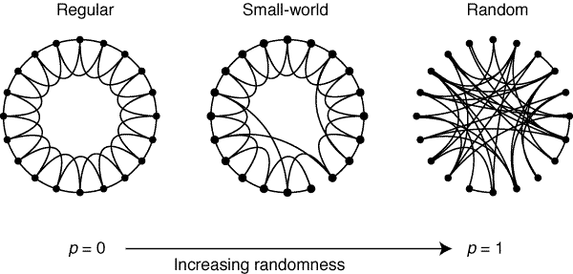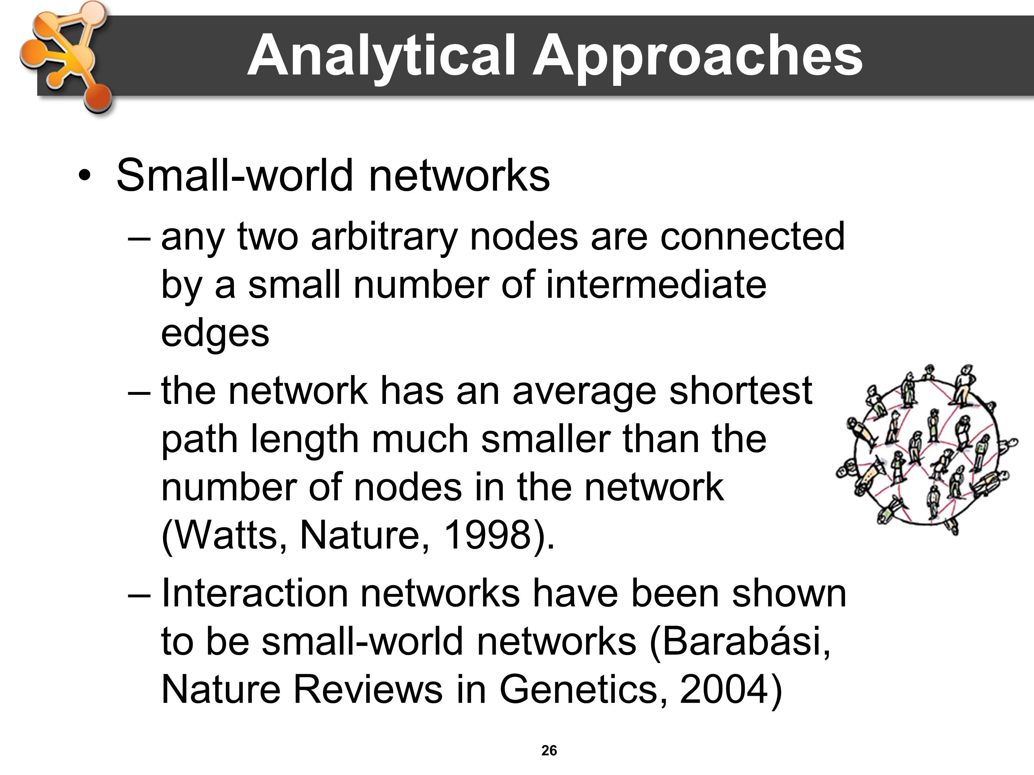One of the striking properties of many empirical networks is that despite their huge size, the average path length is usually surprisingly small [70]. Such networks are called small-world networks.

Formally, a small-world network is defined to be a network where the typical distance *L* between two randomly chosen nodes grows proportionally to the logarithm of the number of nodes *N* in the network:

L ∝ log N

Many real-world systems have small-world properties when represented as networks. They include the WWW, food chains, electric power grids, metabolite processing networks, networks of brain neurons, telephone call graphs, and social influence networks.

Interaction networks are also shown to be small-world networks [51]. This could indicate that local pertrubations such as regulation of the biological activity of a given protein could reach the whole network very quickly.

**Notes**

### Random networks

Random networks (random graphs) are important tools for determining the extent to which a computationally derived network differs from a similar “random network”. This is, in principal, the same idea behind the BLAST expectation value or the *p* value that you might get from a statistical test.

Networks, however, are complicated, and developing an appropriate probability model is non-trivial. There are several algorithms commonly used to generate random networks. In the simplest case, you can just generate a graph, *G(n,p)*, where for any two nodes N1 and N2, there is a probability *p* that there is an edge between them[71]. This is similar to the Erdős-Rényi model([72, 73] as cited in [74]), but in the Erdős-Rényi model, the number of edges is restricted to a fixed number, *M*. Thus, the graph, *G(n,M)*, is a graph where all of the *M* edges appear with equal probability.

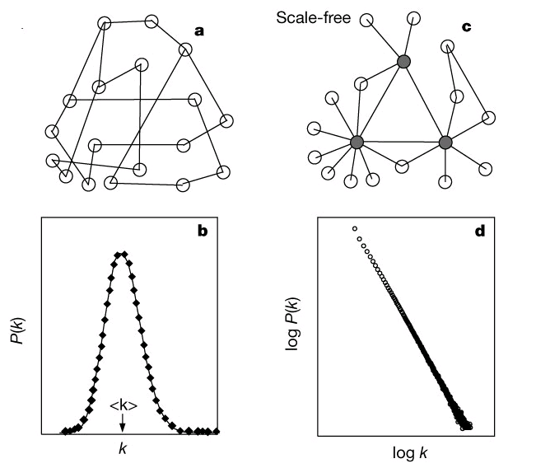The problem with both of these “flat” models is that neither of the models are likely to result in graphs that exhibit the characteristics of biological networks (small world, scale-free) discussed above. One approach to this is to explicitly model the random graph such that it exhibits small-world properties (short average path lengths and high clustering). The is the approach proposed by Watts and Strogatz[70]. In the Watts and Strogatz model, there are three key parameters: the number of nodes, *N*, the mean degree of the nodes, *K*, and a tuning parameter *β*, which is between 0 and 1. The algorithms begins by generating a network with *N* nodes, each connected to *K* neighbors, *K*/2 on each side. Then for every edge (*ni,nj*) rewire that edge with probability *β* such that there are no loops and there is no duplicate edges. The result depends on the value of *β*. If *β* is near zero, the result is a regular lattice. If *β* is one, this approaches the random graph similar to the Erdős-Rényi model with



Another approach is to implement a random graph that is scale-free. The Barabási-Albert model is an approach to generating random scale-free graphs[68]. This approach starts with a small network *G(n,m)*, where *n* is the number of nodes (≥2) and *m* is the number of edges. The requirement is that all nodes have degree of at least 1. Then new nodes are added according to a probability *pi*:



where *ki* is the degree of the node *i*. This results in hubs (nodes with more edges) continuing to get more edges and nodes with fewer edges being less likely to get new edges. This results in a degree distribution that fits the scale-free model quite well, but is still random in nature.

### Network measures

We’ve mentioned the three most common network measures already: node degree, path length, and clustering coefficient. The first two of these are intuitively understandable. The third is a little more difficult to conceptualize since it doesn’t fit our concept of clusters (i.e. groupings of nodes or modularity) very well.

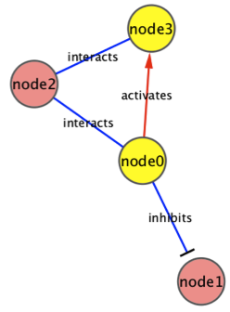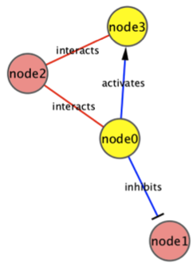Node degree is, as we’ve already mentioned, the number of edges connected to this node. In a directed network, the node *indegree* is the number of edges directed towards this node, and the node *outdegree* is the number of edges directed away from this node. In the network at the right, for example, **node3** has an *indegree* of 2 and an *outdegree* of 1 (assuming we count the undirected edge as both in and out).

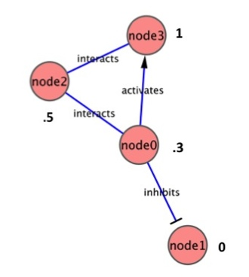Path length is also relatively easy to imagine. If we look for the shortest path from **node0** to **node3** (the first network at the right) it’s the edge between them. On the other hand, the shortest path from **node3** to **node0** goes through **node2** (because the edge between **node0** and **node3** is directed). The length of the path is often just a hop count (1 in the first example, 2 in the second), but can also be weighted, which might mean the shortest path is not the path that traverses the fewest nodes.

The clustering coefficient is a measure of the degree to which nodes form a complete graph. It was originally defined to measure the degree to which a network exhibits small-world properties[70]. For undirected graphs, the local clustering coefficient is given as the number of edges between neighbors of node i divided by the maximum possible number of edges:



In the network example at the right (assuming it’s undirected), **node3** has two neighbors (degree 2), **node2** and **node0** share an edge, so we have (2*1)/2(2-1) = 1. On the other hand, **node0** is degree 3, but only **node2** and **node3** are connected, so we have (2*1)/3(3-1) = .3. The network average clustering coefficient can be used to express the degree to which a graph exhibits small-world properties. The average is simply:



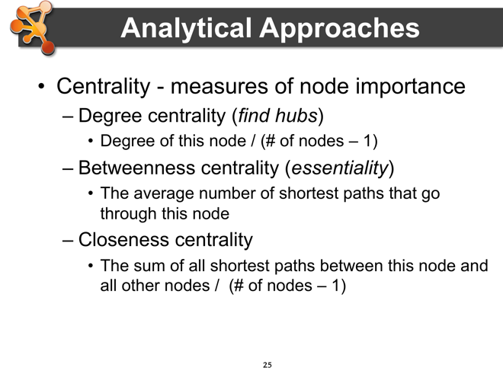Another important set of networks measures that has important properties are the various centrality measures. These approaches (in general) attempt to provide a measure of the importance of a given node. There are many centrality measures, but we’ll just discuss three of them here.

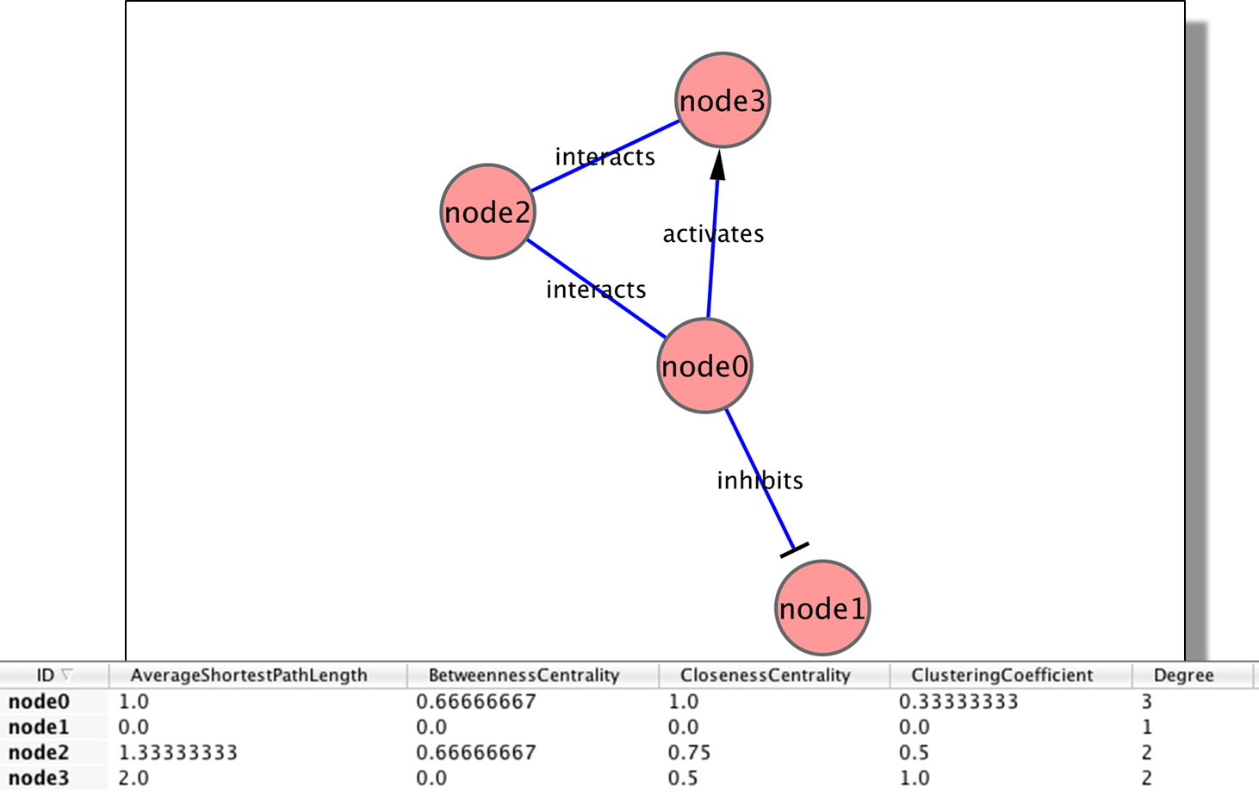The first centrality measure we’ll discuss is *degree centrality*. Nodes with high degree centrality are the hubs in scale-free networks, for example. This is an easy measure to compute the degree centrality (*CD*) of node *v*: , where *n* is the number of nodes in the network.



*Betweenness centrality* is another centrality measure than tends to reflect the essentiality of a node in the network. Essentially it measures the extent to which “all roads lead through” this node. The betweenness centrality for a node *v* is calculated as: , where *σst* is the number of shortest paths from *s* to *t* and *σst* *(v)* is the number of shortest paths from *s* to *t* that go through *v*. Betweenness is usually normalized by dividing with the number of node pairs. Intuitively, this makes sense – if a large percentage of the shortest paths between two nodes go through a given node, removal of that node will have a significant effect on the network topology (from the perspective of those two nodes).



*Closeness centrality* is the degree to which this node is close to all other nodes. It is again calculated based on shortest paths: , where *S(v,t)* is the shortest path between *v* and *t*. So, in a star topology, where all nodes are connected to a single hub, the closeness centrality measure for the hub is 1 and ~2 for all other nodes[2]. This value is usually reported as the inverse, 1/Cc(v).



**Notes**

Clustering

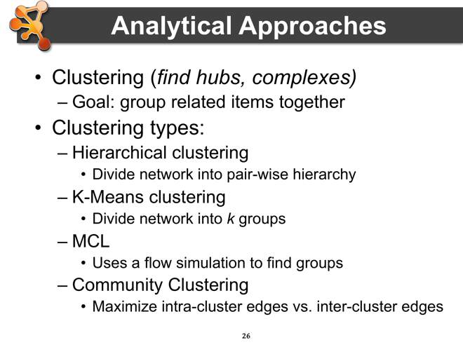Clustering is a heavily used technique for analyzing networks, both biological and otherwise. The overall goal of clustering is to group items together that are related based on some measure. Clustering is an active area of research and there are many clustering algorithms that have long been used for biological applications, and even more algorithms that are being developed for specialized purposes.

Before we talk about specific clustering approaches, it is important to understand that all of the clustering approaches depend on some metric for determining the similarity of the items being clustered. This similarity metric is termed a *distance* metric in clustering terms, and there are a number of ways to calculate the distance in feature space (that is, the terms or values you are using to determine the similarity between objects). A common measure is the *Euclidean* distance, which is simply the distance between two points in n-dimensional space:



Other common techniques are based on the *Pearson correlation*, *r*, between any two series of numbers *x* = (*x1, x2, …, xn*) and *y = (y1, y2, …, yn*), which is defined as:



where σx is the standard deviation of the *x* series, and σy is the standard deviation of the *y* series.

This term can be either *centered* (as above), or *uncentered*, which assumes a mean of zero (even if it’s not). There are many other approaches to calculating the distance, from taking the negative log of the BLAST e-value to much more complicated approaches designed to account for specific characteristics of the data.

#### Hierarchical Clustering

A very common clustering approach is *hierarchical* clustering[75]. As the name implies, this approach divides the objects into a pairwise hierarchy. Hierarchical clustering has been used for many years as one of the major approaches to analyzing and visualizing microarray data[76]. An important first step in performing hierarchical clustering is to determine the distance metric (above). The second step is to determine how to link the pairwise distances[3]:

* *Single linkage* clustering takes the minimum pairwise distance,
* *Complete linkage* clustering takes the maximum pairwise distance,
* *Average linkage* clustering (UPGMA) takes the average of all of the pairwise distances,
* *Centroid linkage* clustering takes the distance between the centroids of all pairs of elements.

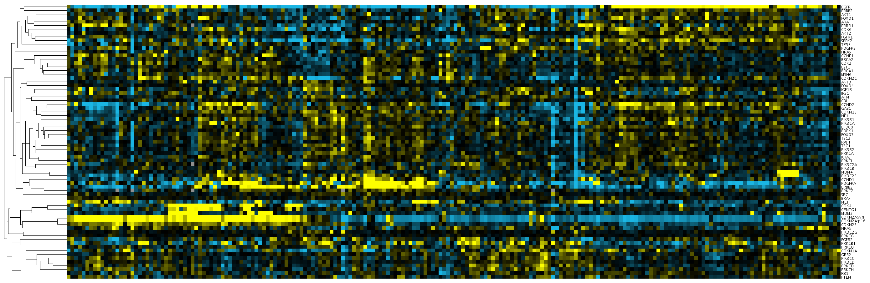Once the metrics and linkages have been selected, clustering may be accomplished by either an *agglomerative* (bottom-up) or *divisive* (top-down) method. In either case, the result is tree (hierarchy) where the nodes closer together in the tree are more similar. For microarray data, this is often shown as a dendrogram associated with the heatmap that reflects the fold changes in the expression data (see the example below).

#### k-Means Clustering

Another common clustering technique is *k-means[**77**,* *78**]*. In k-means clustering the algorithm divides the data set up into *k* groups in such a way that the value of the item gets assigned to the cluster with the nearest mean. The approach is relatively simple: given a set of **n** data items the idea is to partition the **n** items into *k* sets so as to minimize the within-cluster sum of squares (WCSS):



where **S** = (S1, S2, …, Sn) are the clusters and ***u***i are the mean of the points in each cluster *Si*. k-means has been used in a number of applications, and has been incorporated in to a number of other algorithms.

There are many other clustering algorithms and combinations of algorithms used in network applications – far too many for us to cover here. Often these algorithms are general algorithms (e.g. Community clustering[79], MCL[31, 80, 81], Spectral Clustering[82-86], and Affinity Propagation[87, 88]) and often they designed for special purposes (e.g. SCPS[89], MCODE[5], FORCE[90], TransClust[91]). Some algorithms are actually combinations of algorithms (e.g. AutoSOME[92]). We’re going to cover only three of these algorithms (MCL, Spectral, and Affinity Propagation), but the interested reader is encouraged to explore the references below.

#### MCL Clustering

MCL clustering (MCL is short for Markov Clustering) is a clustering approach that simulates a weighted random walk through a network. The idea behind the algorithm is that because edges within the natural groupings will most likely stay within the group, the vast majority of the steps in a random walk will be within the natural group. The other way to think about it is by imagining edges as flows – most of the flow through a network with natural clusters will stay within the clusters – very little will flow between the clusters. The simulation of the random walk is by alternate application of two operations: *expansion* and *inflation*. First, the distance matrix is converted to a stochastic matrix (a non-negative matrix where each of the columns sums to 1). In the expansion step, the stochastic matrix is squared using the normal matrix product. In the inflation step, the Hadamard product of the matrix (entry-wise multiplication by an inflation parameter, *I*) is taken. After the inflation step, a scaling step is added which returns the matrix to a stochastic matrix. Repeated expansion and inflation will have the result of removing cells in the distance matrix (i.e. edges) that represent inter-cluster edges.

MCL clustering has been used for a large number of biological applications, including the finding of protein complexes in protein-protein interaction networks and the grouping of proteins in protein similarity networks. MCL has proven to be very fast and robust with then number of edges is reasonably low, but can have problems resolving dense networks necessitating some form of algorithm or user-chosen cut-off value to reduce the edge density[93]. MCL has the nice characteristic that it does not necessitate the user to select the number of clusters in advance, although the inflation parameter *I* does have to be specified.

#### Spectral Clustering

Spectral clustering takes in name from the use of spectral properties of the similarity (or distance) matrix constructed from the network. Given a set of data points A, the [similarity matrix](http://en.wikipedia.org/wiki/Similarity_matrix) may be defined as a matrix *S* where *Sij* represents a measure of the similarity between points *i* and *j* which are members of the set A. Spectral clustering techniques make use of the [spectrum](http://en.wikipedia.org/wiki/Spectrum_of_a_matrix) of this matrix of the data to perform [dimensionality reduction](http://en.wikipedia.org/wiki/Dimensionality_reduction) for clustering in fewer dimensions.

One such technique is the [Normalized Cuts algorithm](http://en.wikipedia.org/wiki/Segmentation_based_object_categorization#Normalized_Cuts)[94, 95], commonly used for [image segmentation](http://en.wikipedia.org/wiki/Segmentation_%28image_processing%29). It partitions points into two sets (*S*1,*S*2) based on the [eigenvector](http://en.wikipedia.org/wiki/Eigenvector) *v* corresponding to the second-smallest [eigenvalue](http://en.wikipedia.org/wiki/Eigenvalue) of the [Laplacian matrix](http://en.wikipedia.org/wiki/Laplacian_matrix)



of *S*, where *D* is the diagonal matrix



This partitioning may be done in various ways, such as by taking the median *m* of the components in *v*, and placing all points whose component in *v* is greater than *m* in *S*1, and the rest in *S*2. The algorithm can be used for hierarchical clustering by repeatedly partitioning the subsets in this fashion.

A related algorithm is the [Meila-Shi algorithm](http://en.wikipedia.org/w/index.php?title=Meila-Shi_algorithm&action=edit&redlink=1)[82], which takes the [eigenvectors](http://en.wikipedia.org/wiki/Eigenvector) corresponding to the *k* largest [eigenvalues](http://en.wikipedia.org/wiki/Eigenvalue) of the matrix *P* = *SD*−1 for some *k*, and then invokes another (e.g. *k*-means) to cluster points by their respective *k* components in these eigenvectors.

Spectral clustering techniques are very useful in biology, but they have the disadvantage that since they essentially divide the data into two sets, you must either combine them with something like *k*-means or use a hierarchical decomposition to arrive at a more refined clustering.

#### Affinity Propagation

Affinity propagation[87] is a newer algorithm that takes a message passing approach rather than a mathematical approach to clustering. Basically, as with the other approaches, affinity propagation takes a similarity matrix s(*i,j*), which represents the starting point of the algorithm. In addition, each point is given a preference value s(*k,k*) which is used to seed the likelihood of this point being an exemplar for the formation of a cluster (this is often just set to a flat value to allow the algorithm to learn the number of clusters). Then, the points exchange messages of two types: responsibilities (r(*i,k*)) are sent from point *i* to point *k* and reflects the degree to which *k* is a good exemplar for point *i*; and availability (a(*i,k*)) is sent from point *k* to point *i* to reflect the evidence for *i* to choose *k* for its exemplar. The algorithm runs until some stopping point usually based on the degree to which r(*i,k*) and a(*i,k*) change during each pass. See their web site (http:// www.psi.toronto.edu/index.php?q=affinity propagation) for more information about the algorithm and its application.

Affinity propagation has numerous applications in biology and seems to perform well in the datasets provided by the authors. Some comparative analysis by others[96] suggests that other algorithms might be less susceptible to noise and more robust for some applications.

**Notes**

### Guilt by association

Another technique for finding the function of unknown genes is “guilt by association”. The basic idea is simple – if a particular gene or protein is “associated” with one or more other genes or proteins of a particular function, then that gene or protein likely shares that function. A common example is to look at the expression profile of a gene and then match it to a number of genes that are similarly expressed. If all of the genes that are similarly expressed perform a similar function, then this gene probably performs that same function[97].

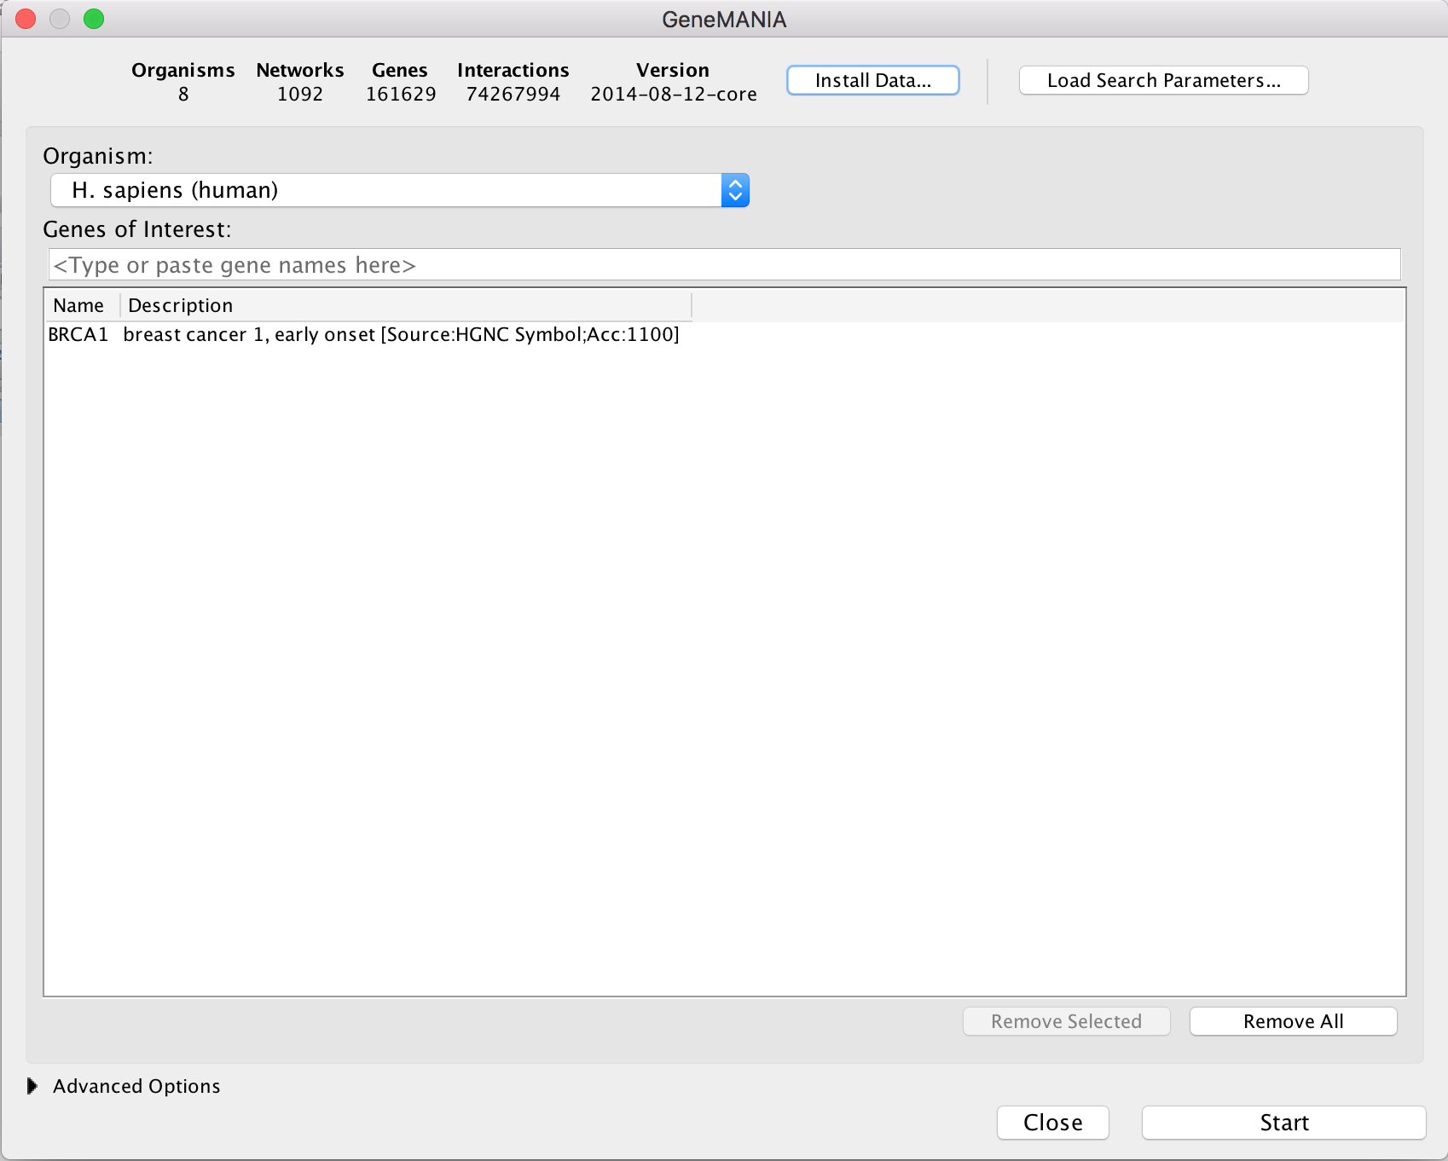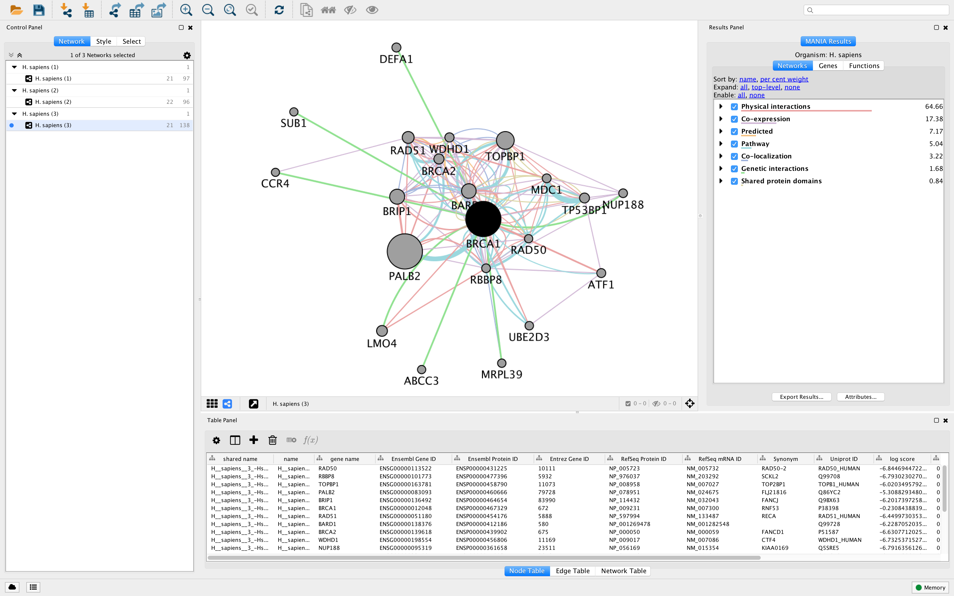Another use of “guilt by association” is to find disease-related proteins. The idea is the same as above – given a gene or protein search for related genes or proteins that are associated with diseases[98]. If they are related closely to the gene of interest, then we might assume that it is also associated with the disease. The pictures at the right show the result of querying GeneMANIA[99-101] with BRCA1, which is known to be associated with breast cancer. The resulting network includes many other breast cancer associated genes, including BRCA2 and PALB2.

**Notes**

### Network motifs

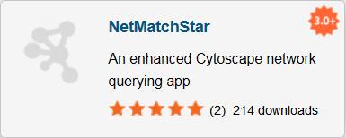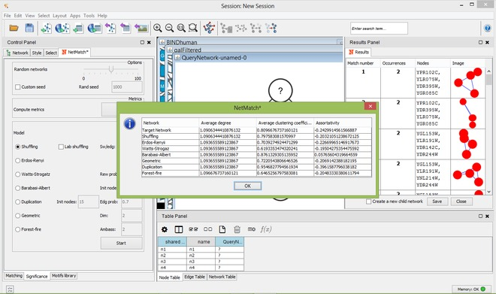A network motif is a pattern of connectivity that occurs more frequently than might be expected by a random connection of nodes[102]. As might be expected by the reuse we often see in biology, biological networks tend to have a small set of network motifs that act like components in a larger circuit[103, 104]. Network motifs have been identified in the gene regulation network of *E. coli*[105] as well as a larger set of networks[106]. There are a number of network motifs that have been identified in biology, including feed forward loops[107-111] (like the one shown at the right), feedback loops[112-114], positive and negative auto-regulation loops[115]. These biological circuits are critical to regulatory processes in the cell, so identifying them in protein-protein interaction networks can provide important clues to the pathway which the protein participate in[116-118].

**Notes**

### Overrepresentation analysis

Overrepresentation analysis (ORA) is an important tool used to identify aspects or attributes of a subset of nodes that are statistically more common in those nodes than in the full set. The most common approach is to cluster a group of genes based on expression data and look for overrepresentation of various gene ontology (GO)[119] terms in the groups to determine if a particular expression pattern suggests a particular biological process[120-123].

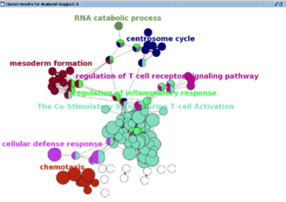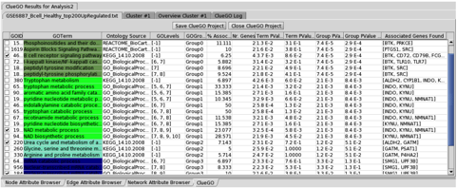

One of the things to keep in mind when doing ORA is that the resultant *p*-values may need to be adjusted since multiple tests are conducted. This makes sense – if we’re performing multiple tests we increase the possibility that we’ll get a false positive based on random chance. Two methods for correcting for multiple tests are the Dunn-Bonferroni Familywise Error Rate (FWER)[124] correction and the Benjamini & Hochberg False Discovery Rate (FDR)[125] correction.

The image at the right shows the results of an overrepresentation analysis of a yeast expression data set using the Cytoscape BiNGO plugin[126].

**Notes**

## Visualization

In the previous sections, we made use of a number of visualization techniques that are easily taken for granted. In this section, we will detail the techniques and key decisions involved in producing network and pathway visualizations. Using biological networks to visualize data is a critical aspect of exploratory analysis: facilitating interpretation, new insights and new hypotheses (PMID: 20824171). We are visual creatures, after all.

### Depiction

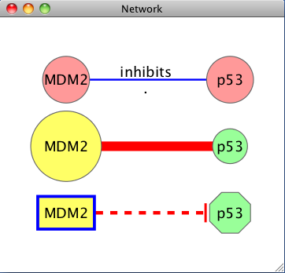

Node and edge motif in various visual styles

The basic visual motif of networks in Cytoscape is that of nodes and edges. In biological networks, the nodes often represent genes, proteins or small molecules, while the edges (or lines) represent interactions and relationships between connected nodes (see figure at the right). Beyond this core motif, all other visual features (e.g., shape, size, color, thickness, label, transparency, etc) are flexible and can be used to represent practically any data value, annotation or attribute.

### Data Mapping

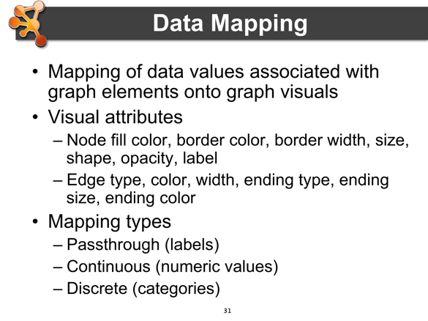The first thing most users want to do in Cytoscape is to map their data onto networks for visualization. The variety of data and network types has already been explored in previous sections. Here, we will focus on the mechanics of data mapping using the VizMapper interface.

VizMapper provides a user interface for controlling the mapping of data attributes to visual attributes. There is a long list of available visual attributes that can be mapped to, including node properties such as fill color, border color, shape, width, height, opacity and label, and edge properties such as type, color, thickness, as well as arrow type, size and color.

**Notes**

Data attributes can be mapped in three main ways: **Passthrough** – directly passing the data value to the visual attribute, e.g., labels. **Continuous** – mapping a continuous range of numerical values to a range of visual attributes, e.g., expression values to a color gradient. **Discrete** – mapping discrete data values (string or numeric) to specified visual attributes, e.g., five different categories to five different colors.

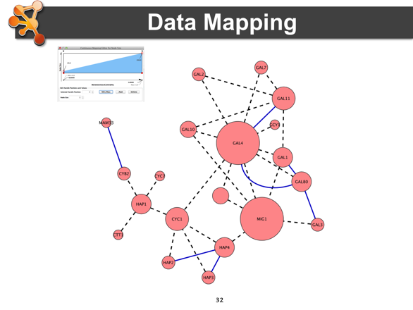The next two examples focus on two types of Continuous data mapping, since these are the most useful and most challenging. First, we map degree-of-connectivity (the data attribute) to node size (the visual attribute), so that more connected nodes appear proportionally larger, thus highlighting potential “hubs.” In the VizMapper interface, you would begin by double-clicking on ‘Node Size’ and selecting the data attribute containing degree information. Then select “Continuous Mapping” type and click the graphic to edit the mapping parameters. The min and max of the data attribute is given as the x-axis and the visual attribute is the y-axis.

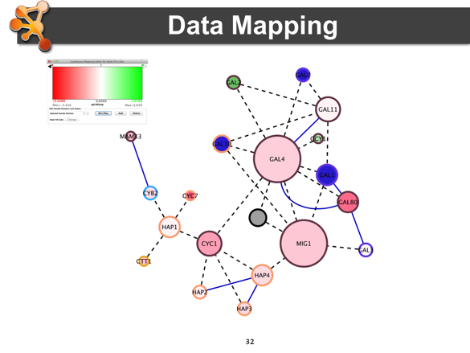The second example maps continuous expression values to node color. Once again in the VizMapper interface, you would double-click the visual attribute, pull-down the data attribute and then choose “Continuous Mapping.” When you click on the graphic, you will notice a different parameterization. Once again, the data attribute is given as the x-axis, but now instead of a y-axis, you will find thresholds that control the ends and mid-point of a color gradient as well as step-function thresholds to set discrete colors for values exceeding the gradient range. This is a handle tool for focusing the continuous mapping of color to a critical range of data.

**Notes**

### Layouts

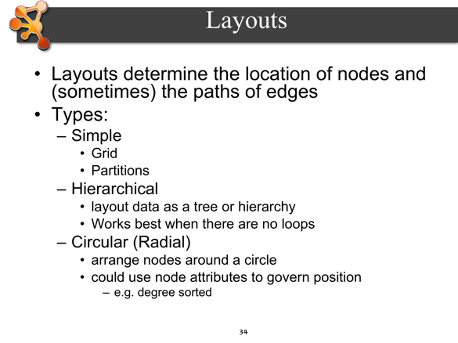The majority of network information does not come with fixed coordinates. With the exception of manually curated pathway diagrams, networks typically rely on automated layout algorithms to position nodes and edges. Cytoscape comes with a wide variety of built-in layout algorithms that can be applied to any pathway or network. In addition, a number of plugin extensions have been developed to support additional layouts.

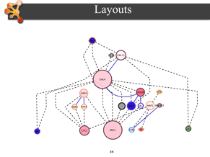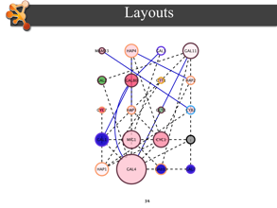Here, we will describe the main layout types natively supported by Cytoscape. You can find these in the menu *Layout > Cytoscape Layouts*.

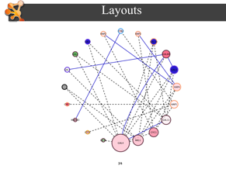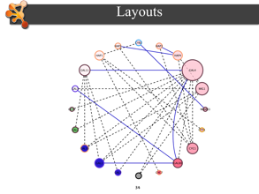**Grid Layout** – a simple layout of nodes in arbitrary order arranged in a grid pattern. This layout does *not* take in account edge crossings, weights or degree of connectivity.

**Group Attributes Layout** – performs a grid layout but orders nodes according to a user-selected attribute, e.g., ascending order based on a numerical attribute.

**Hierarchical** – based on connectivity, this layout defines ordered layers of nodes in a tree structure, e.g., phylogenetic trees.

**Circular Layout** – arranges nodes around the circumference of a circle. The order of the nodes is arbitrary in the basic version. There two other versions: **Attribute Circle Layout**, which orders nodes based on a user-selected attribute, and **Degree Sorted Circle Layout**, which orders nodes based on their number of connections. *Pro-tip: The Degree Sorted Circle Layout calculates the degree for each node and creates a new attribute that can be used for other purposes as well, e.g., data mapping.*

**Notes**

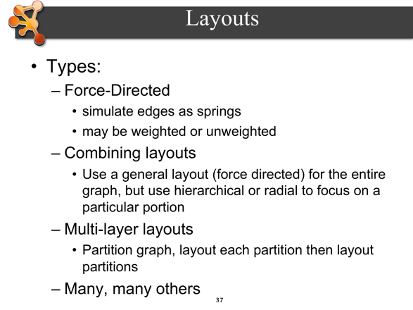**Force-Directed Layout** – simulates edges as springs, resulting in clusters of highly connected nodes with minimally connected nodes spaced and in the periphery. You can also choose to influence the layout based on an edge attribute, if available. A related layout is **Spring Embedded**, which also simulates edges as springs. Both of these layouts also have explicit **Edge-Weighted-** versions that provide more control.

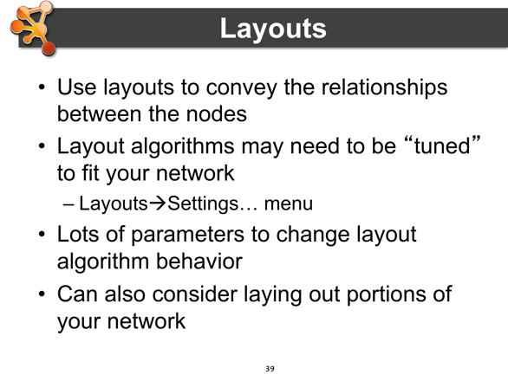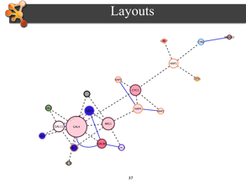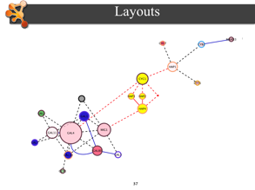Furthermore, you can apply layouts to selected subsets of nodes. If you make a node selection prior to browsing the Layout menu, you will see an additional submenu option to apply the layout to “All nodes” or “Selected Nodes Only.” By using this feature, you can effectively combine different layouts for a single network. For example, after applying a Force-Directed Layout, you could then select a connected subset and apply a Hierarchical Layout just to that set.

To achieve just the right visual layout for your network, you may need to “tune” a layout algorithm. You can do this by going to *Layout > Settings…* and then select the layout algorithm you want to tune. The settings expose the parameters of each algorithm so that you can explore different layout behaviours.

**Notes**

### Animation

There are cases where a static image doesn’t tell the whole story. Perhaps you have collected data in a time series or have more than one condition you want to compare. Animation is a key technique for visualizing change.

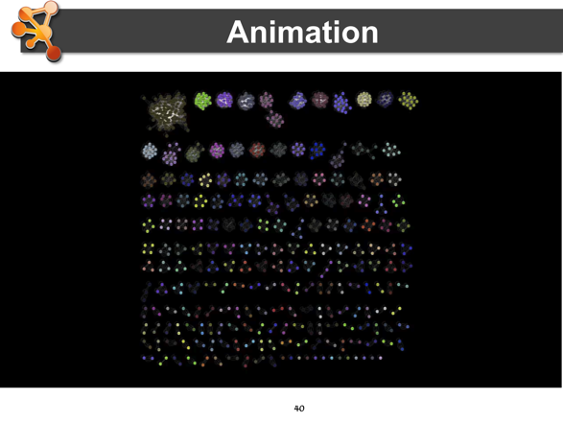There are a handful of plugins for Cytoscape that support automatic, step-wise animation through defined VizMapper styles (e.g., *clusterMaker* and VistaClara). But there is also a dedicated plugin called **CyAnimator** that supports flexible animation creation.

Using CyAnimator, you choose the frames of the animation as you work. Interpolation fills-in the transitions between frames for a wide range of visual features, including position, size, color, and opacity. A final set of images are generated and ready to be imported into a number of free or commercial movie file generators.

**Notes**

# Introduction to Cytoscape

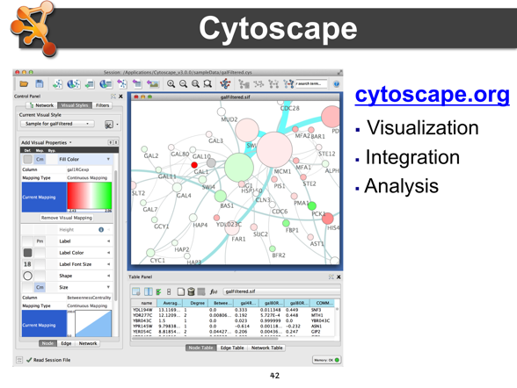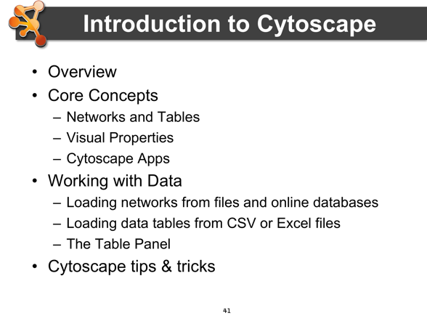***Cytoscape*** is an open source bioinformatics software platform for ***visualizing*** molecular interaction networks and biological pathways and ***integrating*** these networks with annotations, gene expression profiles and other state data.   Although Cytoscape was originally designed for biological research, now it is a general platform for complex network analysis and visualization.   Cytoscape *core* distribution provides a basic set of features for data integration and visualization.   Additional features are available as ***plugins* (now called *Apps*)**.   Plugins are available for network and molecular profiling analyses, new layouts, additional file format support, scripting, and connection with databases.   Plugins may be developed by anyone using the Cytoscape open API based on Java™ technology and plugin community development is encouraged. Most of the plugins are freely available.

Cytoscape is a collaborative project between the Institute for Systems Biology (Leroy Hood lab), the University of California San Diego (Trey Ideker lab), Memorial Sloan-Kettering Cancer Center (Chris Sander lab), the Institut Pasteur (Benno Schwikowski lab), Agilent Technologies (Annette Adler team), the University of Toronto (Gary Bader Lab), Gladstone Institutes (Bruce Conklin and Alex Pico), and the University of California, San Francisco (Tom Ferrin lab).

**Notes**

## Core Concepts

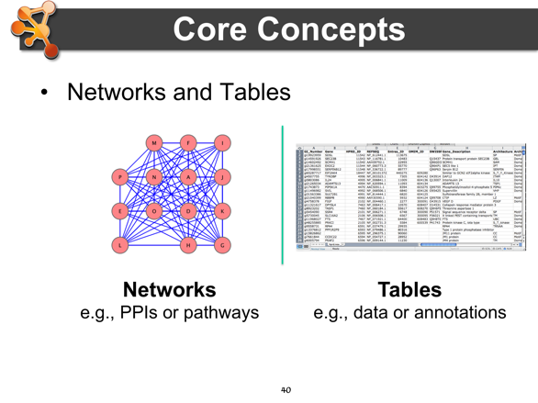Cytoscape creates networks, where nodes of the network represent objects (such as proteins) and connecting edges represent relationships between them (such as physical interactions). Each Edge connects two Nodes. Edges can be directed or undirected. In the case of a directed edge, there is a Source and a Target Node. Once this basic network is created, various attributes of the nodes and edges (such as protein expression levels or strength of interaction) can be added to the network and incorporated as visual cues like shape or color.

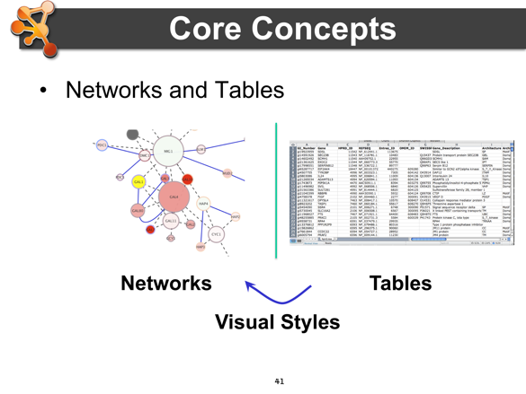

**Notes**

## Visual Styles

One of Cytoscape's strengths in network visualization is the ability to allow users to encode any attribute of their data (name, type, degree, weight, expression data, etc.) as a visual property (such as color, size, transparency, or font type). A set of these encoded or mapped attributes is called a ***Visual Style*** and can be created or edited using the Cytoscape ***VizMapper***. With the VizMapper, the visual appearance of your network is easily customized. For example, you can:

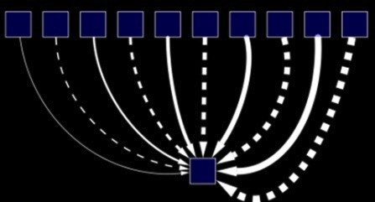

Use specific line types to indicate different types of interactions.

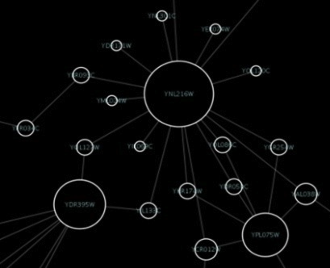

Set node sizes based on the degree of connectivity of the nodes.

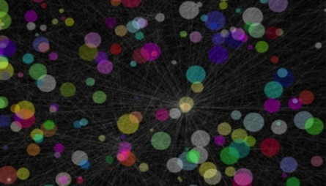

Browse extremely dense networks by controlling for the opacity of nodes.

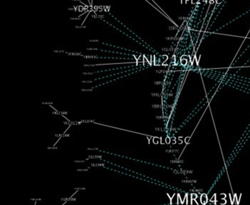

Set node font sizes based on the degree of connectivity of the nodes.

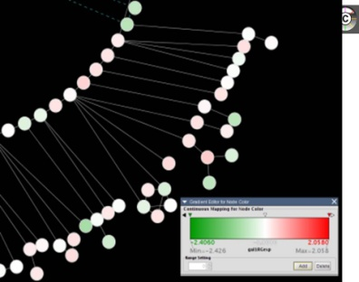

Visualize Gene Expression data its biological context by superimposing colors onto the nodes based upon their Gene Expression data values.

## Apps

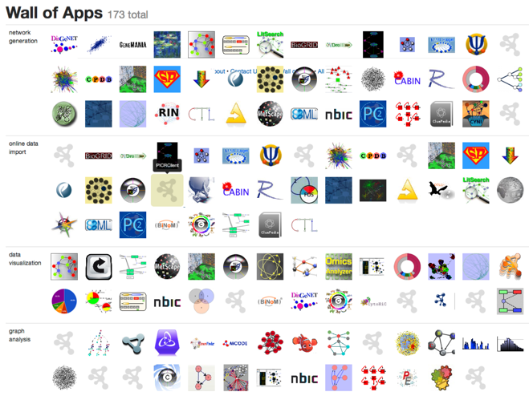Cytoscape allows users to extend its functionality by creating or downloading additional software modules known as “Apps”. These extensions provide additional functionality in areas such as network data query and download services; network data integration and filtering; attribute-directed network layout; GO enrichment analysis7; as well as identification of network motifs, functional modules, protein complexes, or domain interactions.

Links to these apps can be found at http://apps.cytoscape.org

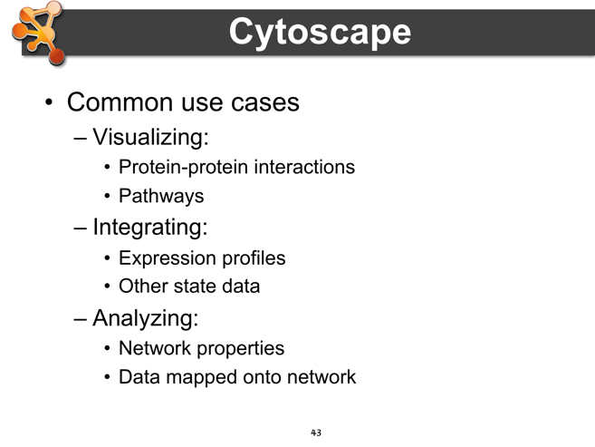Altogether, Cytoscape and its Apps provide a powerful tool kit designed to help researchers answer specific biological questions using large amounts of cellular network and molecular profiling information.

**Notes**

### BiNGO

BiNGO is a Java-based tool to determine which Gene Ontology (GO) categories are statistically overrepresented in a set of genes or a subgraph of a biological network. BiNGO is implemented as a plugin for Cytoscape.

BiNGO maps the predominant functional themes of a given gene set on the GO hierarchy, and outputs this mapping as a Cytoscape graph. Gene sets can either be selected or computed from a Cytoscape network (as subgraphs) or compiled from sources other than Cytoscape (e.g. a list of genes that are significantly upregulated in a microarray experiment).

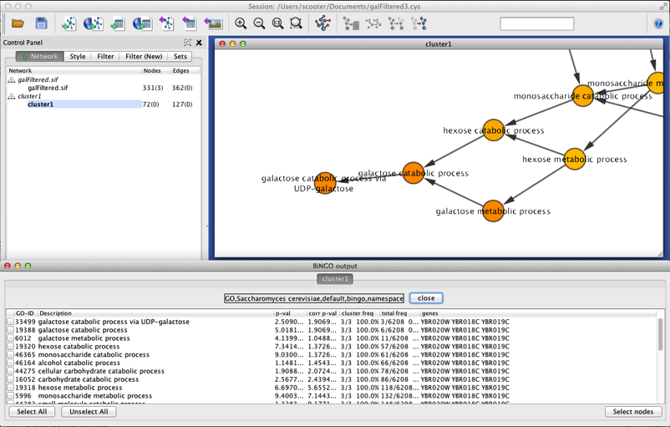

The main advantage of BiNGO over other GO tools is the fact that it can be used directly and interactively on molecular interaction graphs. Another plus is that BiNGO takes full advantage of Cytoscape's versatile visualization environment. This allows you to produce customized high-quality figures.

BiNGO features include:

* Assessing overrepresentation or underrepresentation of GO categories
* Graph or gene list input
* Batch mode: analyze several clusters simultaneously using same settings
* Different GO and GOSlim ontologies
* Wide range of organisms
* Evidence code filtering
* Hypergeometric or binomial test for overrepresentation
* Multiple testing correction using Bonferroni (FWER) or Benjamini&Hochberg (FDR) correction
* Interactive visualization of results mapped on the GO hierarchy.
* Extensive results in tab-delimited text file format
* Ability to make and use custom annotations, ontologies and reference sets

### Agilent Literature Search

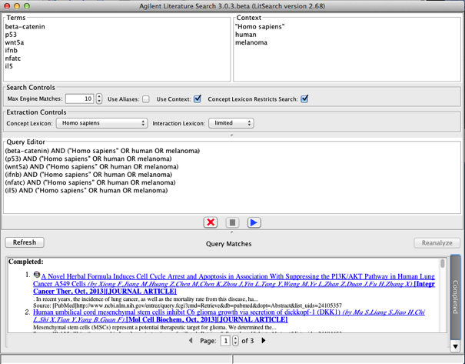Agilent Literature Search Software is a meta-search tool for automatically querying multiple text-based search engines (both public and proprietary) in order to aid biologists faced with the daunting task of manually searching and extracting associations among genes/proteins of interest.

Agilent Literature Search Software can be used in conjunction with [Cytoscape](http://www.agilent.com/home/leaving.shtml?http://www.cytoscape.org/index.php), which provides a means of generating an overview network view of gene/protein associations.

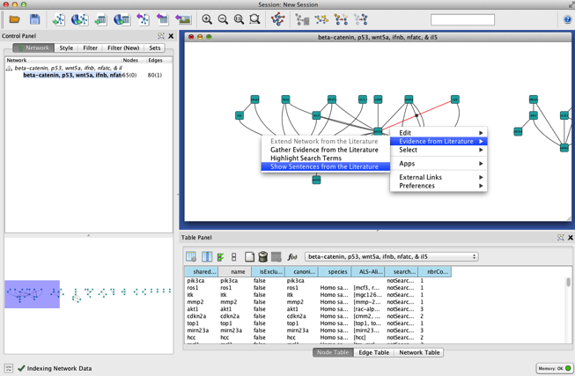Agilent Literature Search software provides an easy-to-use interface to its powerful querying capabilities. When a query is entered, it is submitted to multiple user-selected search engines, and the retrieved results (documents) are fetched from their respective sources. Each document is then parsed into sentences and analyzed for protein-protein associations. Agilent Literature Search Software uses a set of "context" files (lexicons) for defining protein names (and aliases) and association terms (verbs) of interest. Associations extracted from these documents are collected into a Cytoscape network. The sentences and source hyperlinks for each association are further stored as attributes of the corresponding Cytoscape edges.

Agilent Literature Search Plugin Features:

* Meta-search engine combining Information Retrieval & Knowledge Extraction
* PubMed, OMIM, USPTO
* Load/Save/Reanalyze search results
* Paged Search results view
* User context-based aliasing
* File-based lexicon management
* Symbol identification, interaction extraction
* Cytoscape session load/save compatible
* Putative network generation from literature
* Literature-based evidence gathering for Cytoscape Edges
* Extend a Cytoscape network with associations extracted from the literature

## Loading Networks

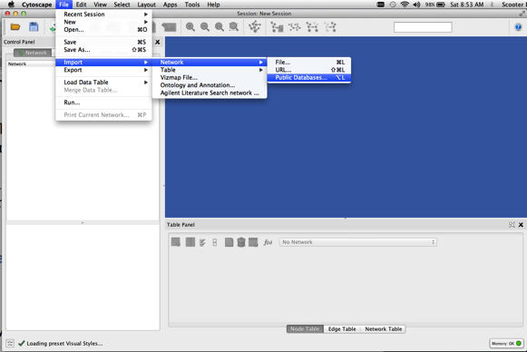There are 4 different ways of creating networks in Cytoscape:

1. Importing networks from Public Databases
2. Importing pre-existing, unformatted text or Excel files.
3. Importing pre-existing, formatted network files..
4. Creating an empty network and manually adding nodes and edges.

### Loading Networks from a Web Service

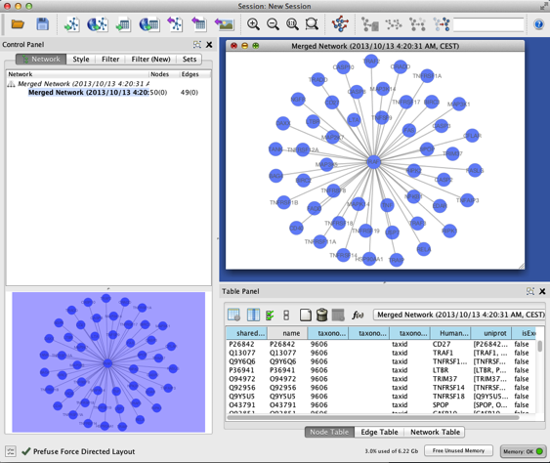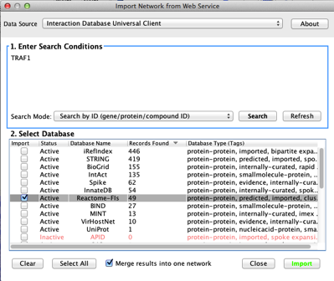In this section we will look at how to import networks using publicly accessible databases.   
  
First, select the **File🡪Import🡪Network** from Public Databases menu item. By default, Cytoscape only provides one public database item (Interaction Database Universal Client), but there are several others available as apps.  
  
  
Step 1: Search. Type in a search term or set of search terms separated by newlines. In this example we use the Interaction Database Universal Client, and enter TRAF1 as our search term.

Step 2: Select. Select Reactome-FIs as our database source and select Import. This will import the interactions provided by Reactome into a Cytoscape network. When the network has successfully loaded, you will see it displayed in the top center panel (Network View). There will also be a ‘birds eye’ overview in bottom-left panel that shows the entire network.

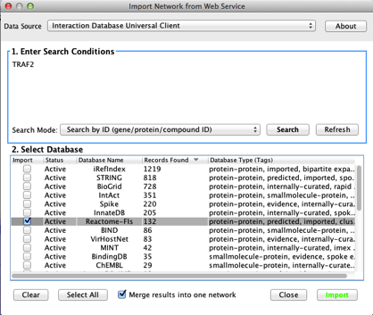

Now let’s extend our network by merging in the known protein-protein interactions for TRAF2. Follow the same procedure as above but this time select TRAF2in Step 1 to search and import the interactions from Reactome.

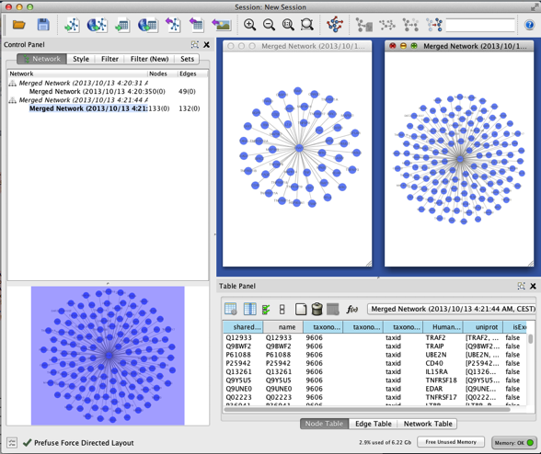

This will bring up the protein-protein interaction network for TRAF2. The image to the right shows the two star networks: one for TRAF1 and one for TRAF2. We can use Cytoscape’s internal tools to merge them.

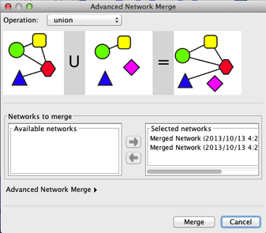

Under the Cytoscape **Tools** menu, select **Merge Networks**. Select both networks (TRAF1 and TRAF2) that you want to merge and click “Merge”.

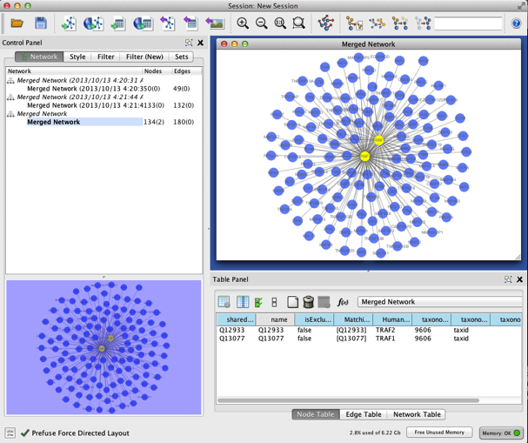

The combined TRAF1/TRAF2 protein-protein interaction network will be displayed (the image at right shows TRAF1 and TRAF2 selected for clarity).

### Load a Network from a Table

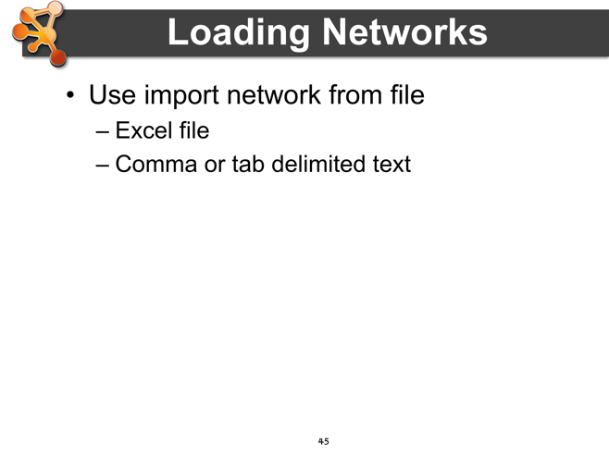In this section we will explore how to create Cytoscape network by importing a pre-existing text or Excel file. The figure at right shows one such example network, consisting of four nodes and four edges.

Let’s begin creating the network by selecting the **File🡪Import🡪Network 🡪 File…** menu item.

In this example, we will import the file *galFiltered.csv*.

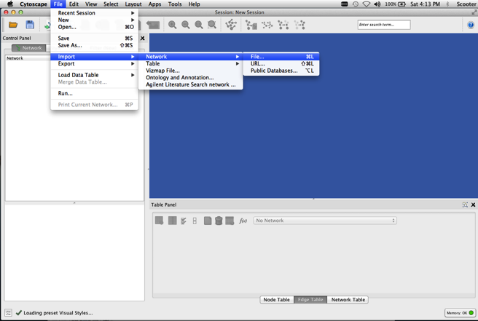**Notes**

An interactive graphical user interface allows you to specify parsing options for specified files. The screen provides a preview that shows how the file will be 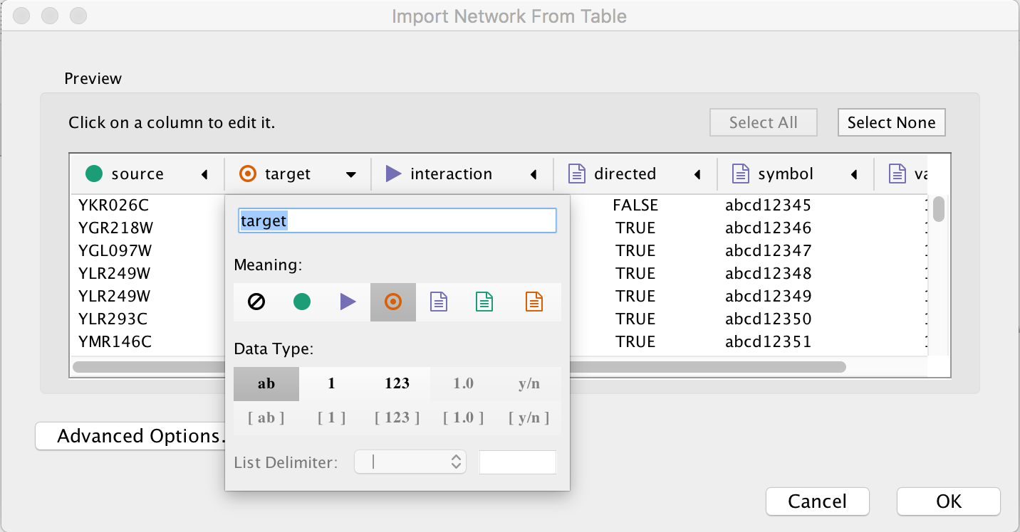interpreted given the current configuration. As the configuration changes, the preview updates automatically. In addition to specifying how the file will be interpreted, you also choose the columns that represent the source nodes (), the target nodes (), an optional edge interaction type (), source attribute (), target attribute (), or edge attribute (). To change the default selection chosen by Cytoscape, click on the arrow in the column heading. The dialog will also allow you to change the column type.

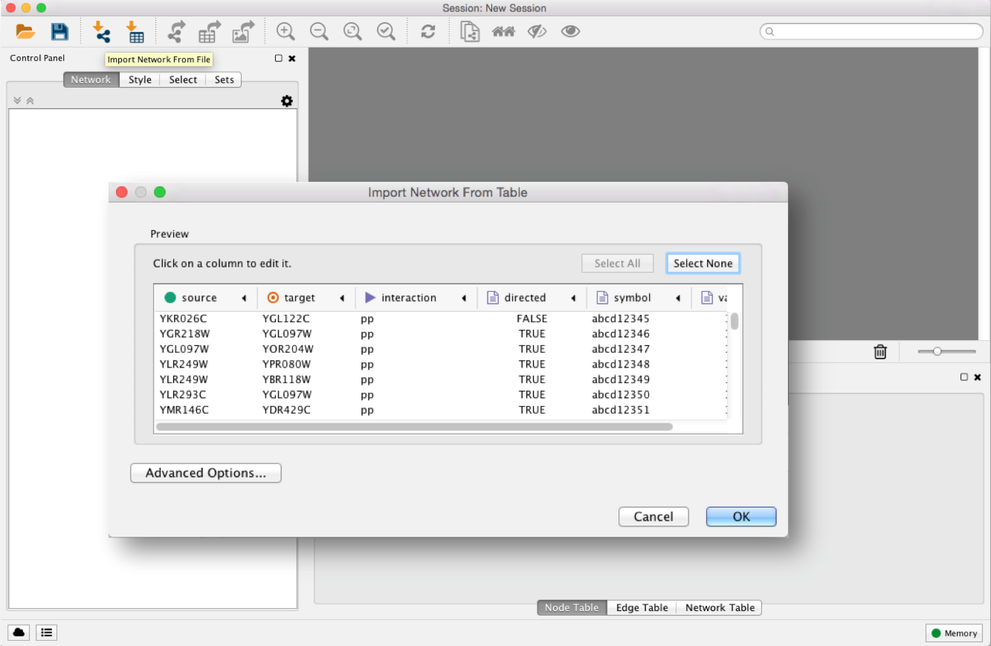Under the **Advanced Options** section, you will see a set of checkboxes appear. These allow you to choose the: 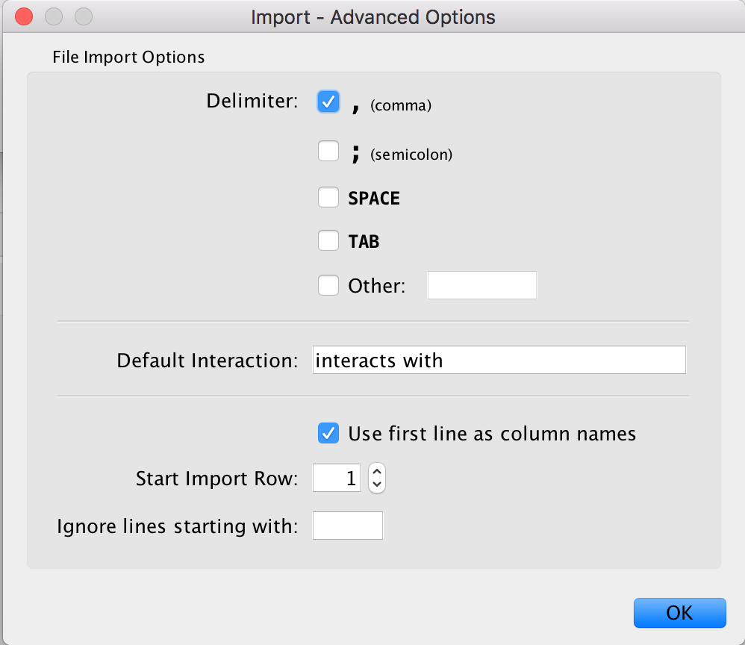

* **Delimiter**. The delimiter character that separates columns (fields) in the import file. This can be a tab, comma, semicolon, space, or any arbitrary delimiter character that you define.
* **Default Interaction**: You can set the name of the Default Interaction type, which is used to name an edge. The example in our figure uses ‘interacts with’ (for protein-protein interaction) as its default interaction.
* **Column Names**. You can choose whether to use the first line of the file to supply column names, one name per delimited column in the file.
* **Start import row**. You can set the import line number so that you can skip over any initial header or **comment** lines in the file.
* **Ignore lines starting with**. You can indicate a character, e.g. ‘#’, to distinguish comment lines in the import files, so that they are not treated as network data.

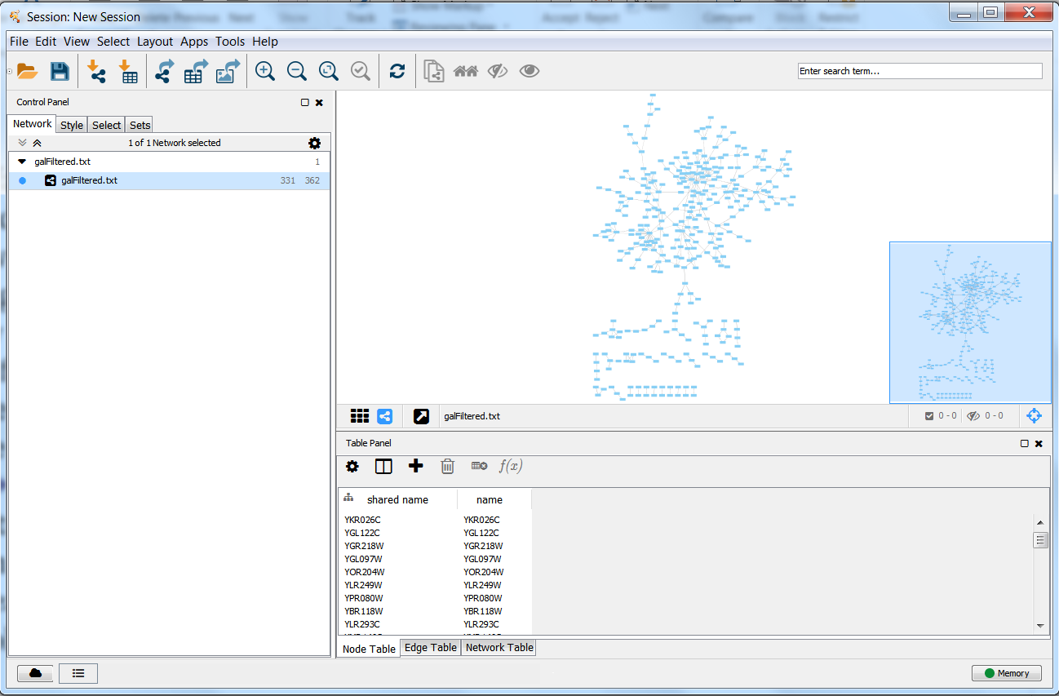When you are satisfied with the settings, press the import button and the network will be imported. You will see a figure that looks like the figure on right.

The values of edge attributes can be used as arguments to graph layout and other computational operations. In the bottom example on right, the attribute for **Weight** is used in the calculation of coordinate positions using Cytoscape’s. **Force-Directed Layout.**

**Notes**

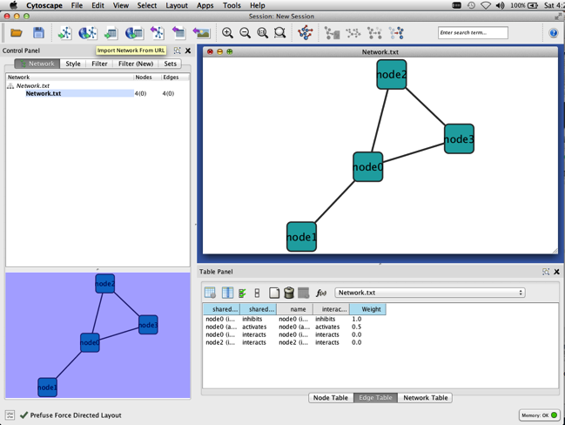

## Load Tables

In this section we will explore how to create Cytoscape attributes and values by importing a pre-existing text or Excel file.

Let’s begin by selecting the **File -> Import -> Table -> File…** menu item. In this example, we import the file *galExpData.csv*.

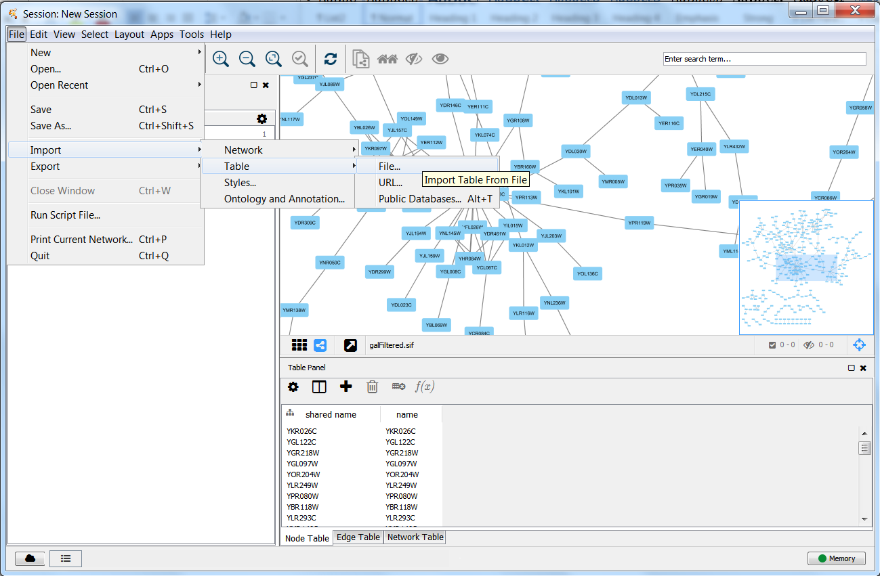The graphical user interface is similar as for creating networks and allows you to interactively specify parsing options for the specified files. The screen provides a preview that shows how the file will be interpreted given the current configuration. As the configuration changes, the preview updates automatically.

**Notes**

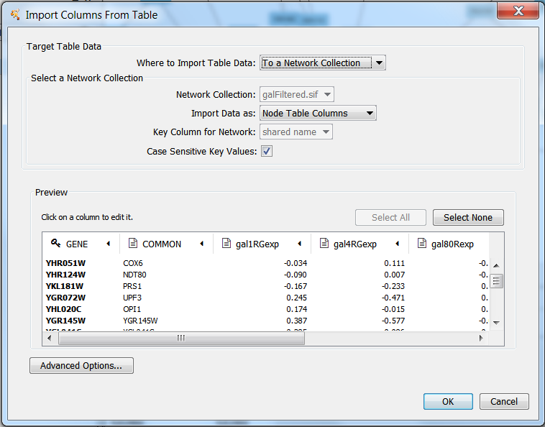

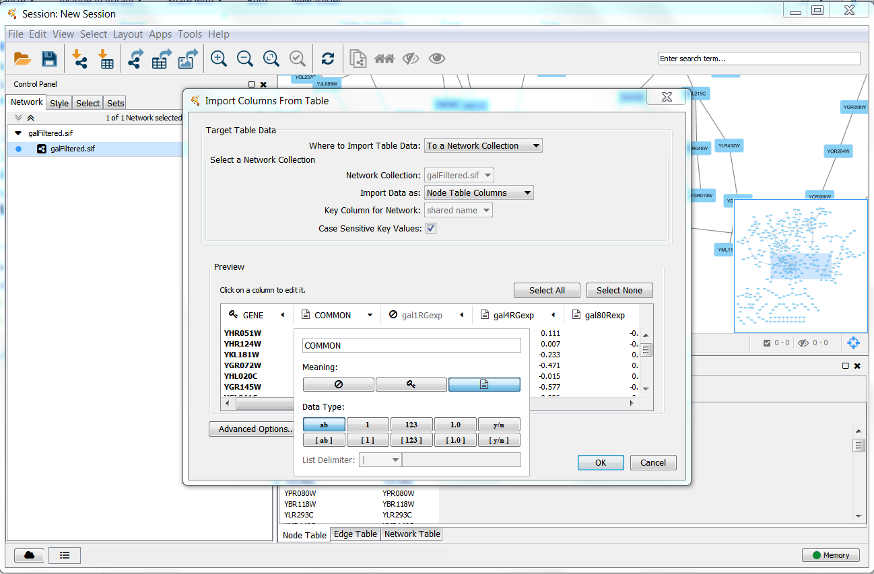To change the default selection chosen by Cytoscape, click on the arrow in the column heading and a dialog box will be displayed. You can change the name for the attribute. You can decide whether the column is imported or not by selecting one of the two options: imported () and not imported ().

You can also set the *Data type* of the elements in the data column, to one of the primitive data types that Cytoscape supports. These are String, Integer, Long Integer, Floating Point, and Boolean. You can also set the Data type of the column to be a list of primitive elements of one datatype.

Now you need to map unique identifiers between the entries in the data and the nodes in the network. The key point of this is to identify which nodes in the network are equivalent to which entries in the table. This enables mapping of data values into visual properties like Color and Shape. This kind of mapping is typically done by comparing the unique Identifier attribute value for each node (**Key Column for Network**) with the unique Identifier value for each data value (). As a default, Cytoscape looks for an attribute value of ‘ID’ in the network and a user-supplied *Key* in the dataset.

The **Key Column for Network** can be changed using a combo box and allows you to set the node attribute column that is to be used as key to map to. The user can change the **Key** by pressingthe key button () for the column that is to be used as key for mapping values in the dataset.

If there is a match between the value of a Key in the dataset and the value the Key Column for Network field in the network, then all attribute-value pairs associated with the element in the dataset are assigned as well to the matching node in the network.

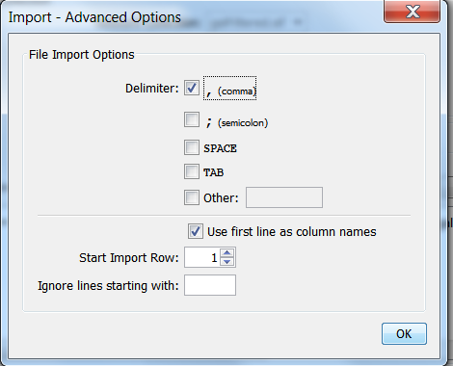Under the **Advanced Options** section, you will see a set of checkboxes appear. These allow you to choose the:

* **Delimiter**. The delimiter character that separates columns (fields) in the import file. This can be a tab, comma, semicolon, space, or any arbitrary delimiter character that you define.
* **Column Names**. You can choose whether to use the first line of the file to supply column names, one name per delimited column in the file.
* **Start import row**. You can set the import line number so that you can skip over any initial header or **comment** lines in the file.
* **Ignore lines starting with**. You can indicate a character, e.g. ‘#’, to distinguish comment lines in the import files, so that they are not treated as network data.

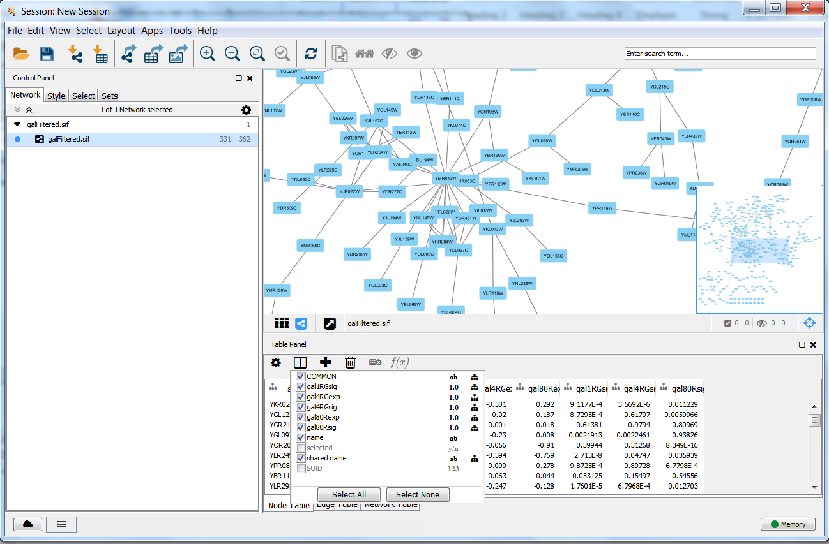Once attributes are imported, we can inspect them in the Table Panel. Right clicking on the  icon in the toolbar will bring up a menu of checkboxes. If you check a checkbox for any attribute in that attribute list, its values will be displayed as a column of values on the Table Panel. The attribute list also contains information about the Data type of each column and if it belongs to the whole network collection or only to the current network.

If you a select a node in the network, its attribute values will be displayed in the control panel, but by default, if no nodes are selected, all attribute rows are shown.

**Notes**

# Tips and Tricks

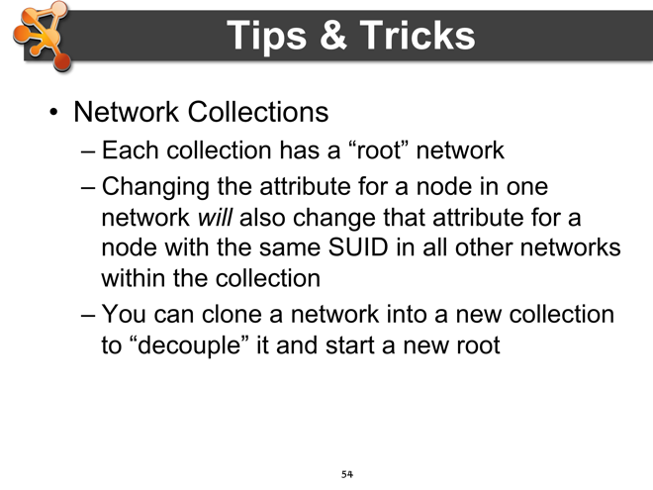Cytoscape is a large, complex, and dynamic software system. A little knowledge of the internals organization and operational model of the software will enable more efficient use of the software. Here are some useful Tips & Tricks to help you get the most out of your Cytoscape usage.

## The ‘”Root Graph”

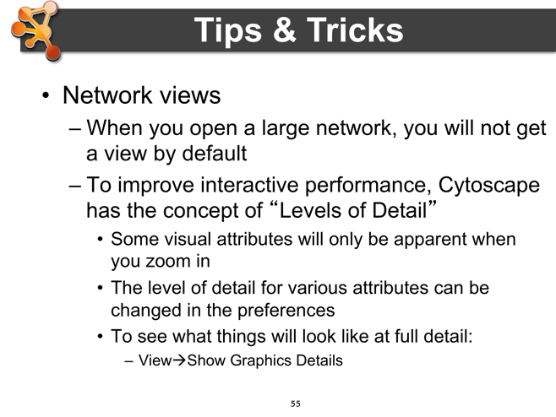There is one central *root graph* that contains all nodes and edges. Thus all networks are ‘views’ on that single graph, and nodes and edges are unique across all networks. Modifying a node in one network will modify that node in all other networks that it appears in. There is no way to have two or more copies of a node with the same ID. The only workaround would be to make a copy of a Cytoscape session.

## Network Views

For efficiency in dealing with large networks, a view is not automatically generated when the size of the network is over a user-definable threshold. You can manually generate a Network View by right-clicking on its entry in the Network Navigator Panel (upper left o Cytoscape desktop)., then selecting ‘Create View’. You can also use that right-menu item to ‘Destroy View’, ‘Destroy Network”, and edit the Network’s title.

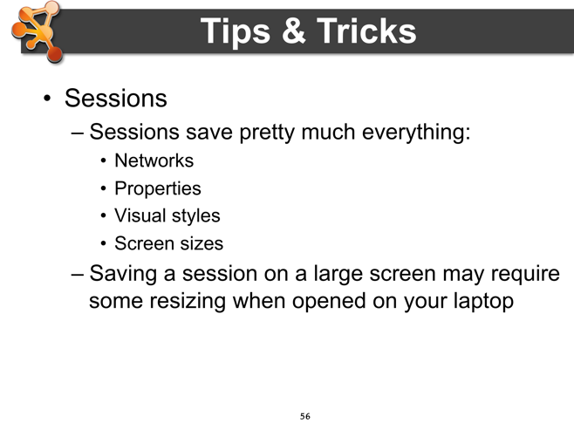To improve interactive performance, Cytoscape has the concept of *Levels of Detail*?This is basically a mechanism for *semantic zooming*,where different levels of detail com into play at different levels of detail (think of the Google Maps interface where a City is represented by a yellow patch at high level then shows more of the structure of streets and avenues as you zoom in.

Some Cytoscape attributes will only be apparent when you zoom in. The level of detail for various attributes can be changed in the preferences. To see what things look like in full detail, select the **View🡪Show Graphics Details** menu item..

## Sessions

Sessions save pretty much everything: Networks, Properties. Visual styles, Screen sizes, and many other types of information. When working on a complex study of workflow, it is often prudent to save one’s intermediate results as a session, so that the current state of an activity is persisted and can be resumed without having to repeat earlier low-level operations. Not all state is the same, however. For example, saving a session on a large screen may require some resizing when re-opened.

## Task Monitor

The Cytoscape task monitor will show the messages for the current task and all of the completed tasks. You can show the task monitor by clicking its icon in the lower left-hand corner.

Cytoscape will also log more detailed messages to the framework-cytoscape.log file in CytoscapeConfiguration/3 directory.

## Memory

Cytoscape uses a lot of memory and, as a Java system, doesn’t like to let go of it. When working with large networks, an occasional save session and restart will help clear out memory. Another efficiency measure is to destroy large network views when not needed.

Cytoscape now provides a memory indicator in the lower right-hand corner of the window. This will tell you if you have enough memory (green) or you are running out of memory (yellow, red). Details are available by clicking the button and you will be given the option to “Free Unused Memory” to lower memory as much as possible.

## Final points on Tips and Tricks

* CytoscapeConfiguration directory
  + This directory is typically located under your home directory, for example on a Macintosh system it will be under

/Users/<username>

* + Your defaults and any plugins downloaded from the app manager will go in this directory. Also, apps may use this directory to store configuration
  + Sometimes,, if things get really messed up, deleting (or renaming) this directory can give you a “clean slate”
* App manager
  + This is where you search/install/update/uninstall apps
  + You now have the option of disabling vs. uninstalling…
  + Can also install and update apps directly from the App Store website, if you have Cytoscape 3 up and running

**Notes**

# Demo/Sample use cases

## Use case 1: Expression data analysis

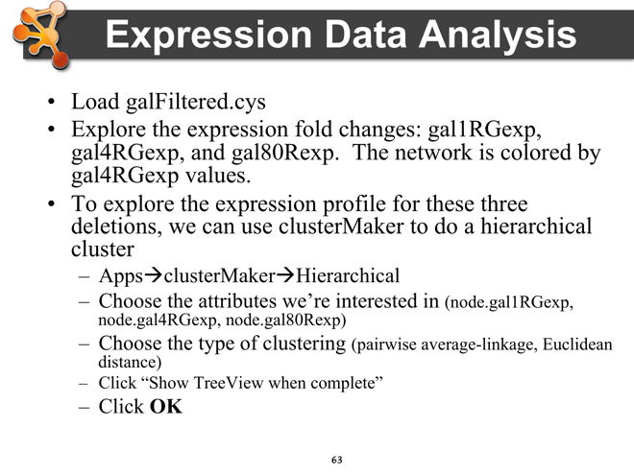This use case highlights the visual display of expression data, integrated clustering features, and basic Gene Ontology overrepresentation analysis. *Note: we are starting with an expression dataset that has already been normalized, statistically analyzed, formatted, imported and associated with an interaction network.*

#### The dataset

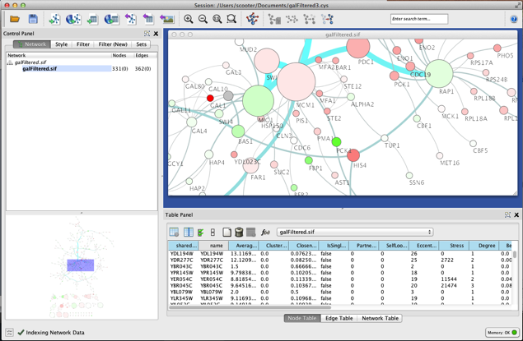Differential gene expression of GAL deletion mutants grown in the presence and absence of galactose[127]. Fold values were mapped onto a protein-protein interaction network focusing on galactose utilization in yeast, *Saccharomyces cerevisiae*. Additional annotations (e.g., gene and protein identifiers, GO terms, pathway associations, etc) have also been added as node attributes. This dataset is included with the download of Cytoscape in the sampleData folder and is called **galFiltered.cys**.

Locate and open the galFiltered.cys session file. Check out the VizMapper settings for node color. By default, the nodes are colored by the fold value **gal4RGexp.** Explore the visualization of other fold values in the dataset: **gal1RGexp** and **gal80Rexp**.

**Notes**

#### Cluster analysis

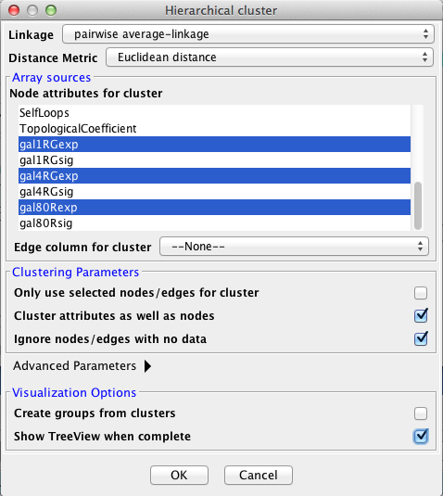To explore the expression profiles for the three deletions, we can perform clustering within Cytoscape using the **clusterMaker** app.

In the Apps menu, select clusterMaker > Hierarchical.

* Choose the type of clustering:
  + pairwise average-linkage
* Choose the attributes of array data:
  + node.gal1RGexp
  + node.gal4RGexp
  + node.gal80Rexp
* Check **Show Treeview when complete**
* 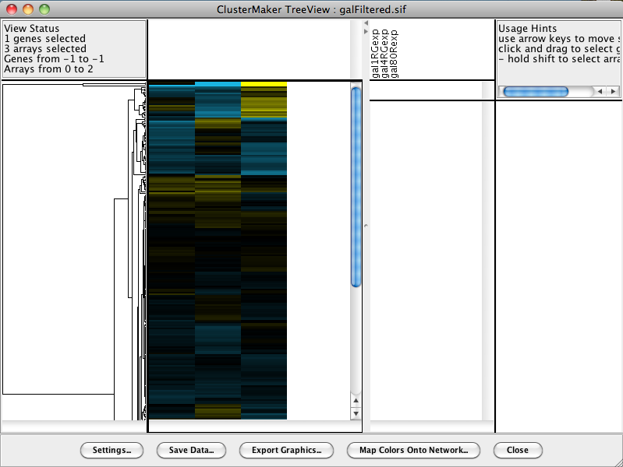Click: **OK**

This will bring up the TreeView of your cluster results. Each row is a gene and the three columns correspond to the three data attributes. A dendrogram to the left expresses the relationship between clusters, and the region to the right shows a close-up and labeled view of selected rows.

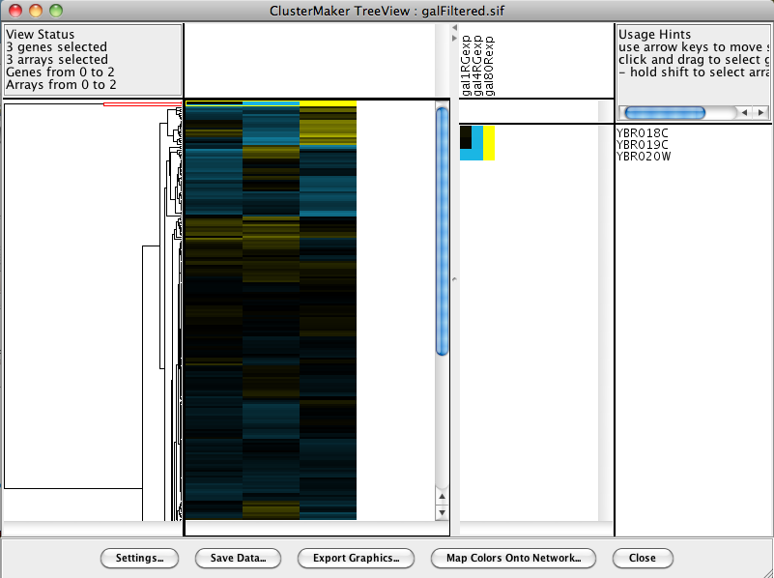If the colors are too dark, or if you prefer other colors altogether, you can open Settings… and adjust a number of preferences.

Now, select the top most branch of the dendrogram, as shown on the right. *Notice that selections in TreeView correspond to selections in the network!*

**Notes**

#### GO term overrepresentation analysis

Now we can see if any of the selected genes from that first cluster show any GO term overrepresentation. In other words, are there particular GO terms that are enriched (or overrepresented) in this subset of genes? We can do this using the **BiNGO** app.

* Apps > BiNGO
* Give the cluster a name
* Click: Start BiNGO
* 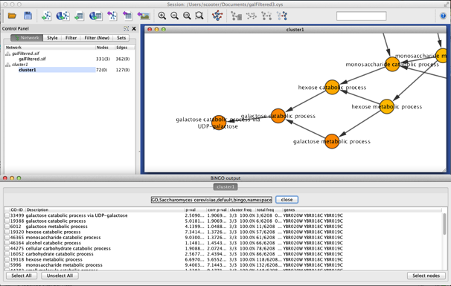*Note: there are many parameters you can play with. The defaults are usually sufficient for a first pass as major trends.*

The results are displayed as a table and as a network of GO associations. The GO terms are connected based on their inherent hierarchical relationship and they are colored based on the significance of their overrepresentation in your cluster.

**Notes**

#### Active modules

Using the jActiveModules app, we can also identify clusters that show differential expression over user-specified conditions or time-points. Here, we will use the p-values for the differential expression of the GAL deletion mutants.

* Select the jActiveModules tab in the Control Panel
* Choose the galFiltered.sif interaction network
* Choose the attributes that contain the differential expression p-values:
  + 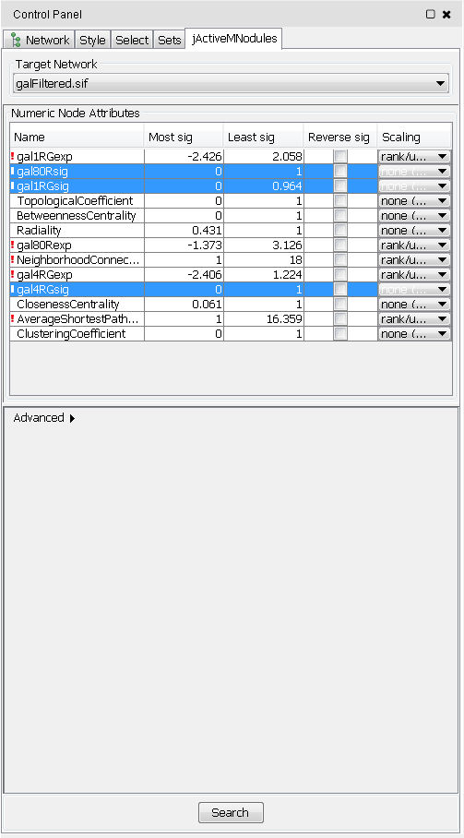gal1RSig,
  + gal4RSig
  + gal80RSig
* Click Search

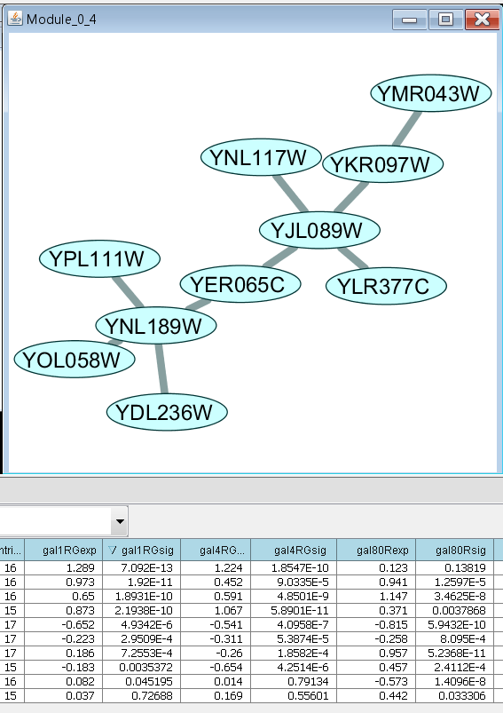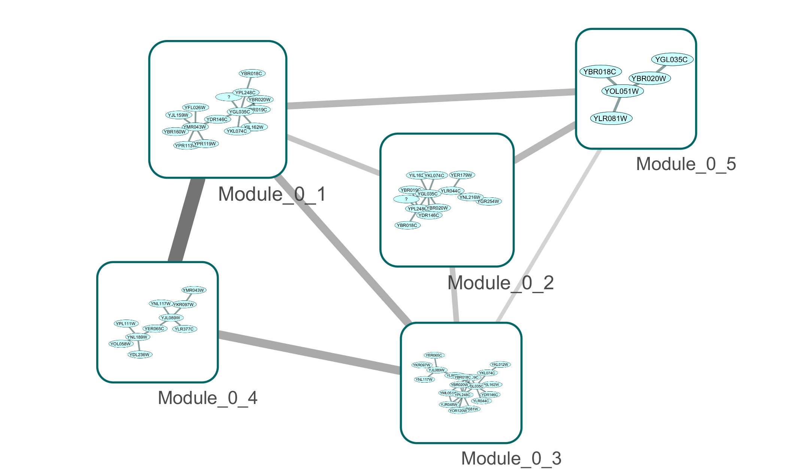This will invoke the creation of several new networks: one for each cluster identified by jActiveModules and one overview network of all modules. Each node in the overview network has a node score that shows how significant the identified module is and the edges are weighted by the number of nodes they share. Each module network has the same attributes as the original network and we can look at the significance values in the Node Table panel.

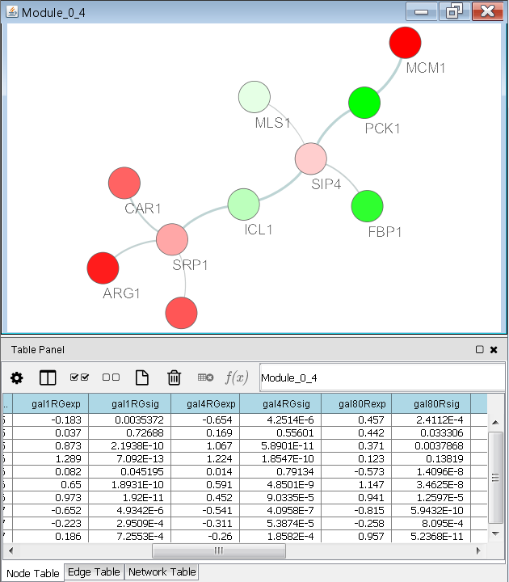**Notes**

## Use case 2: Protein complexes in protein-protein interaction networks

This use case highlights the combined use of MCL clustering of protein-protein interaction (PPI) networks and hierarchical clustering of epistatic mini-array profile (EMAP) data to explore potential biological protein complexes.

#### The dataset

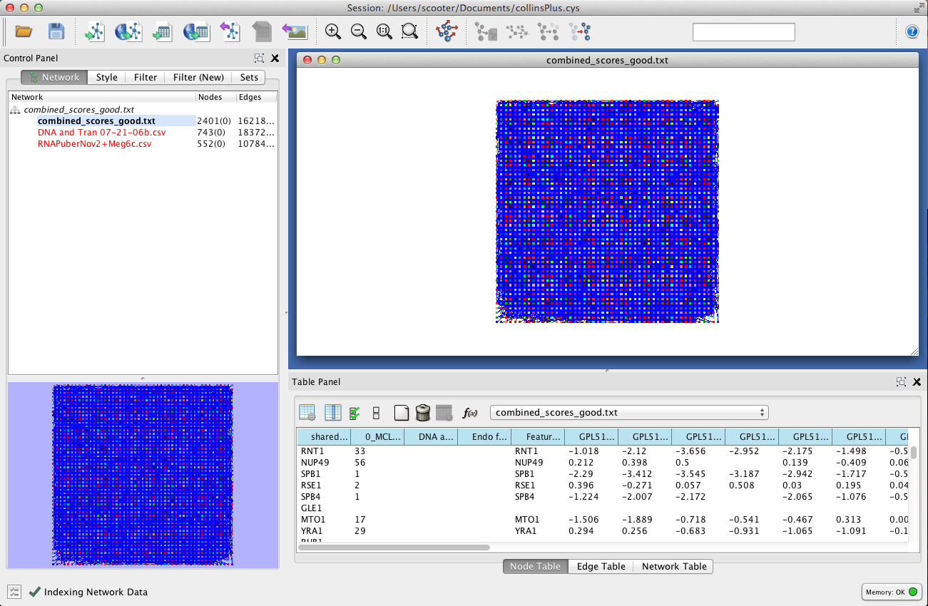We will be working with a Cytoscape session file containing three networks: one is a yeast PPI[27] and the other two are yeast EMAP datasets [7, 128]. *Note: we will not bother viewing the EMAP datasets as networks, but rather treat them as sets of nodes and attributes. You can perform clustering on sets of nodes without creating a network view!* The key to making this analysis work is having the same node identifiers in both the PPI and EMAPs.

The dataset is provided with this tutorial and is called **collinsPlus.cys**:

* combined_scores_good.txt (PPI)
* DNA and Tran 07-21-06b.csv (EMAP)
* RNAPuberNov2+Meg6c.csv (EMAP)

**Notes**

#### MCL clusters in the PPI network

First, we will identify the MCL clusters in the protein-protein interaction network. Under the Plugins menu, choose Cluster and then MCL cluster:

* Density Parameter: 1.8
* Array source: PE Score
* Check **Create new clustered network** and **Restore inter-cluster edges after layout**
* Click: OK

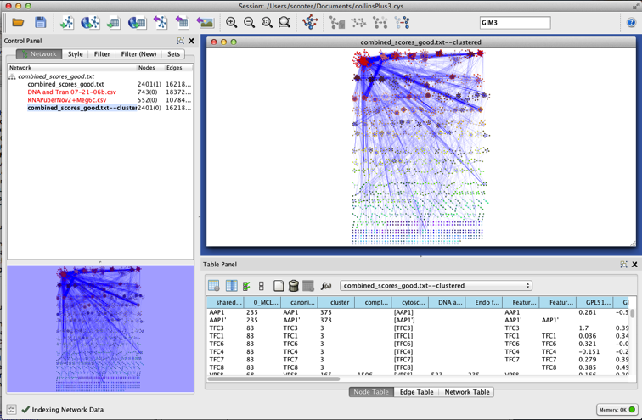There are your MCL clusters. Beautiful, aren’t they! These are our first approximation of potential protein complexes based solely on tightly interacting protein clusters.

Next, we consider the clusters generated from EMAP data as an orthogonal form of evidence based on genetic interactions. Combining both cluster results provides a more complete picture.

**Notes**

#### Hierarchical clustering of EMAP data

Select the “DNA and Tran…” dataset in the Network panel on the left. *Note: the red highlight simply indicates that no network view has been created. No problem.* Once again, go to Apps > clusterMaker > Hierarchical Cluster:

* Linkage: pairwise average-linkage
* Distance Metric: Uncentered correlation
* Edge column for cluster: DNA Strenth
* Check: **Show TreeView when complete**
* Click **OK**

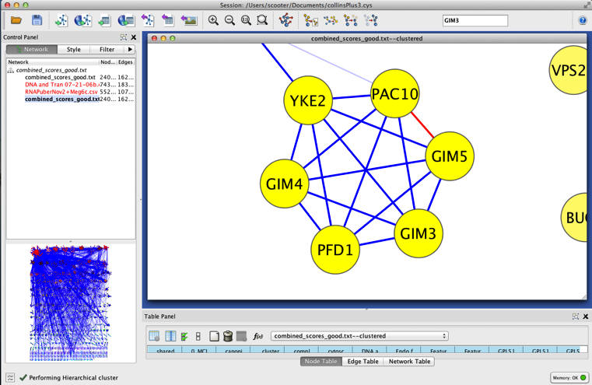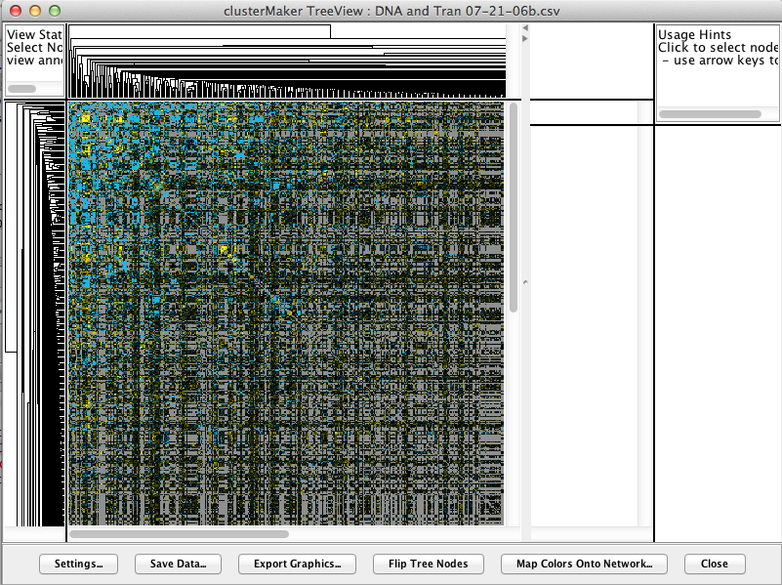

The EMAP clusters identify potential complexes based on genetic (functional) interactions. Now, we can explore the correspondence of evidence from these two methods. For example, search for GIM5 and select the entire cluster. Notice how the corresponding interactions are dynamically highlighted in the TreeView. Notice how both EMAP and PPI data do not provide strong support for the inclusion of BUD27 in this potential complex.

**Notes**

# Hands-on tutorial: Introduction to Cytoscape

This tutorial will cover:

1. Navigating Cytoscape
2. Visualizing Data on Networks
3. Network and Pathway Resources
4. Plugin Manager
5. Plugin Demos

By the end of the tutorial, you should be able to use Cytoscape to import networks and attributes and visualize those attributes on the network.

**Notes**

# Hands-on tutorial: Working with data

This tutorial will introduce you to:

1. Searching Internet interaction databases with query terms.
2. Mapping Identifiers of different types to networks.
3. Finding your query terms in the downloaded network.

The second half of the tutorial will introduce you to some advanced basics in Cytoscape:

1. Apply filters to filter out low-confidence edges.
2. Perform basic edits using the Cytoscape graph editor.

**Notes**

# Hands-on tutorial: Analysis of microarray data

This tutorial will introduce you to:

1. Combining data from two different sources: experimental data in the form of microarrray expression data and network data in the form of interaction data.
2. Visualizing networks using expression data.
3. Filtering networks based on expression data.

**NOTE**: The expression data used in this example has been pre-processed to work with the interaction network used.

**Notes**

# Bibliography

1. Ideker T, Ozier O, Schwikowski B, Siegel AF: **Discovering regulatory and signalling circuits in molecular interaction networks**. *Bioinformatics* 2002, **18 Suppl 1**:S233-240.

2. Breitling R, Amtmann A, Herzyk P: **Graph-based iterative Group Analysis enhances microarray interpretation**. *BMC Bioinformatics* 2004, **5**:100.

3. Bandyopadhyay S, Kelley R, Ideker T: **Discovering regulated networks during HIV-1 latency and reactivation**. *Pac Symp Biocomput* 2006:354-366.

4. Qiu YQ, Zhang S, Zhang XS, Chen L: **Detecting disease associated modules and prioritizing active genes based on high throughput data**. *BMC Bioinformatics* 2010, **11**:26.

5. Bader GD, Hogue CW: **An automated method for finding molecular complexes in large protein interaction networks**. *BMC Bioinformatics* 2003, **4**:2.

6. Bandyopadhyay S, Kelley R, Krogan NJ, Ideker T: **Functional maps of protein complexes from quantitative genetic interaction data**. *PLoS computational biology* 2008, **4**(4):e1000065.

7. Collins SR, Miller KM, Maas NL, Roguev A, Fillingham J, Chu CS, Schuldiner M, Gebbia M, Recht J, Shales M *et al*: **Functional dissection of protein complexes involved in yeast chromosome biology using a genetic interaction map**. *Nature* 2007, **446**(7137):806-810.

8. Krogan NJ, Cagney G, Yu H, Zhong G, Guo X, Ignatchenko A, Li J, Pu S, Datta N, Tikuisis AP *et al*: **Global landscape of protein complexes in the yeast Saccharomyces cerevisiae**. *Nature* 2006, **440**(7084):637-643.

9. Vlasblom J, Wu S, Pu S, Superina M, Liu G, Orsi C, Wodak SJ: **GenePro: a Cytoscape plug-in for advanced visualization and analysis of interaction networks**. *Bioinformatics* 2006, **22**(17):2178-2179.

10. Florez AF, Park D, Bhak J, Kim BC, Kuchinsky A, Morris JH, Espinosa J, Muskus C: **Protein network prediction and topological analysis in Leishmania major as a tool for drug target selection**. *BMC Bioinformatics* 2010, **11**:484.

11. Bansal M, Della Gatta G, di Bernardo D: **Inference of gene regulatory networks and compound mode of action from time course gene expression profiles**. *Bioinformatics* 2006, **22**(7):815-822.

12. Emig D, Salomonis N, Baumbach J, Lengauer T, Conklin BR, Albrecht M: **AltAnalyze and DomainGraph: analyzing and visualizing exon expression data**. *Nucleic acids research* 2010, **38**(Web Server issue):W755-762.

13. Liu S, Zhang C, Zhou Y: **Domain graph of Arabidopsis proteome by comparative analysis**. *J Proteome Res* 2005, **4**(2):435-444.

14. Kann MG, Jothi R, Cherukuri PF, Przytycka TM: **Predicting protein domain interactions from coevolution of conserved regions**. *Proteins* 2007, **67**(4):811-820.

15. Vailaya A, Bluvas P, Kincaid R, Kuchinsky A, Creech M, Adler A: **An architecture for biological information extraction and representation**. *Bioinformatics* 2005, **21**(4):430-438.

16. Kohler S, Bauer S, Horn D, Robinson PN: **Walking the interactome for prioritization of candidate disease genes**. *Am J Hum Genet* 2008, **82**(4):949-958.

17. Kann MG: **Protein interactions and disease: computational approaches to uncover the etiology of diseases**. *Brief Bioinform* 2007, **8**(5):333-346.

18. Mohammad Shafkat Amin AB, Russel L. Finley, Jr., Hasan Jamin: **A stochastic approach to candidate disease gene subnetwork extraction**. In: *2010 ACM Symposium on Applied Computing*. 2010.

19. Dobrin R, Zhu J, Molony C, Argman C, Parrish ML, Carlson S, Allan MF, Pomp D, Schadt EE: **Multi-tissue coexpression networks reveal unexpected subnetworks associated with disease**. *Genome biology* 2009, **10**(5):R55.

20. King JY, Ferrara R, Tabibiazar R, Spin JM, Chen MM, Kuchinsky A, Vailaya A, Kincaid R, Tsalenko A, Deng DX *et al*: **Pathway analysis of coronary atherosclerosis**. *Physiol Genomics* 2005, **23**(1):103-118.

21. Chuang H, Ressenti, L., Ideker, T., Kipps, T.: **Interactome-based modeling and diagnosis of Chrinic Lymphocytic Leukemia**. In: *50th Annual Meeting of the American Society of Hematology*. 2008.

22. Chuang HY, Lee E, Liu YT, Lee D, Ideker T: **Network-based classification of breast cancer metastasis**. *Mol Syst Biol* 2007, **3**:140.

23. Mileyko Y, Joh RI, Weitz JS: **Small-scale copy number variation and large-scale changes in gene expression**. *Proceedings of the National Academy of Sciences of the United States of America* 2008, **105**(43):16659-16664.

24. Chen L, Xuan J, Wang Y, Hoffman EP, Riggins RB, Clarke R: **Identification of condition-specific regulatory modules through multi-level motif and mRNA expression analysis**. *Int J Comput Biol Drug Des* 2009, **2**(1):1-20.

25. McLendon R, et. al.: **Comprehensive genomic characterization defines human glioblastoma genes and core pathways**. *Nature* 2008, **455**(7216):1061-1068.

26. Moraru, II, Schaff JC, Slepchenko BM, Blinov ML, Morgan F, Lakshminarayana A, Gao F, Li Y, Loew LM: **Virtual Cell modelling and simulation software environment**. *IET Syst Biol* 2008, **2**(5):352-362.

27. Collins SR, Kemmeren P, Zhao XC, Greenblatt JF, Spencer F, Holstege FC, Weissman JS, Krogan NJ: **Toward a comprehensive atlas of the physical interactome of Saccharomyces cerevisiae**. *Mol Cell Proteomics* 2007, **6**(3):439-450.

28. Keiser MJ, Roth BL, Armbruster BN, Ernsberger P, Irwin JJ, Shoichet BK: **Relating protein pharmacology by ligand chemistry**. *Nat Biotechnol* 2007, **25**(2):197-206.

29. Atkinson HJ, Morris JH, Ferrin TE, Babbitt PC: **Using sequence similarity networks for visualization of relationships across diverse protein superfamilies**. *PLoS One* 2009, **4**(2):e4345.

30. Yildirim MA, Goh KI, Cusick ME, Barabasi AL, Vidal M: **Drug-target network**. *Nat Biotechnol* 2007, **25**(10):1119-1126.

31. Enright AJ, Van Dongen S, Ouzounis CA: **An efficient algorithm for large-scale detection of protein families**. *Nucleic Acids Res* 2002, **30**(7):1575-1584.

32. Scheeff ED, Bourne PE: **Structural evolution of the protein kinase-like superfamily**. *PLoS computational biology* 2005, **1**(5):e49.

33. Jaccard P: **Distribution de la flore alpine dans le bassin des Dranses et dans quelques régions voisines.** *Bulletin del la Société Vaudoise des Sciences Naturelles* 1901, **37**:241-272.

34. Tanimoto TT. In: *IBM Internal Report.* 1957.

35. Tversky A: **Features of similarity**. *Psychological Review* 1977, **84**(4):327-352.

36. **Daylight Theory: Fingerprints** [<http://www.daylight.com/dayhtml/doc/theory/theory.finger.html>]

37. Altschul SF, Gish W, Miller W, Myers EW, Lipman DJ: **Basic local alignment search tool**. *Journal of molecular biology* 1990, **215**(3):403-410.

38. Altschul SF, Madden TL, Schaffer AA, Zhang J, Zhang Z, Miller W, Lipman DJ: **Gapped BLAST and PSI-BLAST: a new generation of protein database search programs**. *Nucleic acids research* 1997, **25**(17):3389-3402.

39. Smith TF, Waterman MS: **Identification of common molecular subsequences**. *Journal of molecular biology* 1981, **147**(1):195-197.

40. Shindyalov IN, Bourne PE: **Protein structure alignment by incremental combinatorial extension (CE) of the optimal path**. *Protein Eng* 1998, **11**(9):739-747.

41. Holm L, Sander C: **Mapping the protein universe**. *Science* 1996, **273**(5275):595-603.

42. Taylor WR, Flores TP, Orengo CA: **Multiple protein structure alignment**. *Protein Sci* 1994, **3**(10):1858-1870.

43. Ilyin VA, Abyzov A, Leslin CM: **Structural alignment of proteins by a novel TOPOFIT method, as a superimposition of common volumes at a topomax point**. *Protein Sci* 2004, **13**(7):1865-1874.

44. Kolbeck B, May P, Schmidt-Goenner T, Steinke T, Knapp EW: **Connectivity independent protein-structure alignment: a hierarchical approach**. *BMC Bioinformatics* 2006, **7**:510.

45. Guerler A, Knapp EW: **Novel protein folds and their nonsequential structural analogs**. *Protein Sci* 2008, **17**(8):1374-1382.

46. Bausch P, Bumgardner, J.: **Make a Flickr-Style Tag Cloud**. In: *Flickr Hacks.* O'Reilly Press.; 2006.

47. **ISO/IEC JTC1/SC34/WG3** [<http://www.isotopicmaps.org/>]

48. Pegg SC, Brown SD, Ojha S, Seffernick J, Meng EC, Morris JH, Chang PJ, Huang CC, Ferrin TE, Babbitt PC: **Leveraging enzyme structure-function relationships for functional inference and experimental design: the structure-function linkage database**. *Biochemistry* 2006, **45**(8):2545-2555.

49. **Graph theory** [<http://en.wikpedia.org/wiki/Graph_theory>]

50. Bondy JA, Murty, U.S.R.: **Graph Theory with Applications**. In*.*

51. Barabasi AL, Oltvai ZN: **Network biology: understanding the cell's functional organization**. *Nat Rev Genet* 2004, **5**(2):101-113.

52. Jeong H, Mason SP, Barabasi AL, Oltvai ZN: **Lethality and centrality in protein networks**. *Nature* 2001, **411**(6833):41-42.

53. Jeong H, Tombor B, Albert R, Oltvai ZN, Barabasi AL: **The large-scale organization of metabolic networks**. *Nature* 2000, **407**(6804):651-654.

54. Fell DA, Wagner A: **The small world of metabolism**. *Nat Biotechnol* 2000, **18**(11):1121-1122.

55. Ma HW, Zeng AP: **The connectivity structure, giant strong component and centrality of metabolic networks**. *Bioinformatics* 2003, **19**(11):1423-1430.

56. Maslov S, Sneppen K: **Specificity and stability in topology of protein networks**. *Science* 2002, **296**(5569):910-913.

57. Rzhetsky A, Gomez SM: **Birth of scale-free molecular networks and the number of distinct DNA and protein domains per genome**. *Bioinformatics* 2001, **17**(10):988-996.

58. Wuchty S: **Scale-free behavior in protein domain networks**. *Mol Biol Evol* 2001, **18**(9):1694-1702.

59. Tong AH, Lesage G, Bader GD, Ding H, Xu H, Xin X, Young J, Berriz GF, Brost RL, Chang M *et al*: **Global mapping of the yeast genetic interaction network**. *Science* 2004, **303**(5659):808-813.

60. van Noort V, Snel B, Huynen MA: **The yeast coexpression network has a small-world, scale-free architecture and can be explained by a simple model**. *EMBO Rep* 2004, **5**(3):280-284.

61. Featherstone DE, Broadie K: **Wrestling with pleiotropy: genomic and topological analysis of the yeast gene expression network**. *Bioessays* 2002, **24**(3):267-274.

62. Agrawal H: **Extreme self-organization in networks constructed from gene expression data**. *Phys Rev Lett* 2002, **89**(26):268702.

63. Khanin R, Wit, E.: **How Scale-Free Are Biological Networks**. *Journal of Computational Biology* 2006, **13**(3):810-818.

64. Albert R, Jeong H, Barabasi AL: **Error and attack tolerance of complex networks**. *Nature* 2000, **406**(6794):378-382.

65. Stumpf MP, Wiuf C, May RM: **Subnets of scale-free networks are not scale-free: sampling properties of networks**. *Proceedings of the National Academy of Sciences of the United States of America* 2005, **102**(12):4221-4224.

66. Stumpf MP, Ingram, P.J.: **Probablity models for degree distribution of protein interaction networks.** *Europhys Lett* 2005, **71**(1):152-158.

67. Stumpf MP, INgram, P.J., Nouvel, I., Wiuf, C.: **Statistical model selection methods applied to biological network data.** *Trans Comp Syst Biol* 2005, **3**:65-77.

68. Barabasi AL, Albert R: **Emergence of scaling in random networks**. *Science* 1999, **286**(5439):509-512.

69. Barabasi AL: **Scale-free networks: a decade and beyond**. *Science* 2009, **325**(5939):412-413.

70. Watts DJ, Strogatz SH: **Collective dynamics of 'small-world' networks**. *Nature* 1998, **393**(6684):440-442.

71. Gilbert EN: **Random Graphs**. *Ann Math Stat* 1959, **30**(4):1141-1144.

72. Erdős P, Rényi, A.: **On Random Graphs, I.** *Publicationes Mathematicae* 1959, **6**:290-297.

73. Erdős P, Rényi, A.: **The Evolution of Random Graphs**. *Magyar Tud Akad Mat Kutató Int Közl* 1960, **5**:17-61.

74. **Erdős–Rényi model** [<http://en.wikipedia.org/wiki/Erd%C5%91s%E2%80%93R%C3%A9nyi_model>]

75. Ward JH: **Hierarchical Grouping to Optimize an Objective Function**. *Journal of the Americal Statistical Association* 1963, **58**(301):236-244.

76. Eisen MB, Spellman PT, Brown PO, Botstein D: **Cluster analysis and display of genome-wide expression patterns**. *Proc Natl Acad Sci U S A* 1998, **95**(25):14863-14868.

77. MacQueen JB: **Some Methods for classification and Analysis of Multivariate Observations**. In: *5th Berkeley Symposium on Mathematical Statistics and Probability: 1967*. University of California Press: 281-297.

78. Steinhaus H: **Sur la division des corps matériels et parties**. *Bull Acad Polon Sci* 1956, **4**(12):801-804.

79. Newman ME, Girvan M: **Finding and evaluating community structure in networks**. *Phys Rev E Stat Nonlin Soft Matter Phys* 2004, **69**(2 Pt 2):026113.

80. van Dongen S: **A cluster algorithm for graphs**. In*.* Amsterdam: National Research Institue in the Netherlands; 2000.

81. van Dongen S: **Graph Clustering by Flow SImulation**. University of Utrecht; 2000.

82. Meila M, Shi, J.: **A random walks view of spectral segmentation**. In: *International Workshop on AI and Statistics*. 2001.

83. Fiedler M: **Algebraic connectivity of graphs**. *Czech Math J* 1973, **23**:298-305.

84. Fiedler M: **A property of eigenvectors of non-negative symmetric matrices and its application to graph theory.** *Czech Math J* 1975, **25**:619-633.

85. Donath WE, Hoffman, A.J.: **Lower bounds for paritioning of graph.s**. *IBM J Res Develop* 1973, **17**:420-425.

86. Paccanaro A, Casbon JA, Saqi MA: **Spectral clustering of protein sequences**. *Nucleic acids research* 2006, **34**(5):1571-1580.

87. Frey BJ, Dueck D: **Clustering by passing messages between data points**. *Science* 2007, **315**(5814):972-976.

88. Givoni IE, Frey BJ: **A binary variable model for affinity propagation**. *Neural Comput* 2009, **21**(6):1589-1600.

89. Nepusz T, Sasidharan R, Paccanaro A: **SCPS: a fast implementation of a spectral method for detecting protein families on a genome-wide scale**. *BMC Bioinformatics* 2010, **11**:120.

90. Wittkop T, Baumbach J, Lobo FP, Rahmann S: **Large scale clustering of protein sequences with FORCE -A layout based heuristic for weighted cluster editing**. *BMC Bioinformatics* 2007, **8**:396.

91. Wittkop T, Emig D, Lange S, Rahmann S, Albrecht M, Morris JH, Bocker S, Stoye J, Baumbach J: **Partitioning biological data with transitivity clustering**. *Nat Methods* 2010, **7**(6):419-420.

92. Newman AM, Cooper JB: **AutoSOME: a clustering method for identifying gene expression modules without prior knowledge of cluster number**. *BMC Bioinformatics* 2010, **11**:117.

93. Apeltsin L, Morris JH, Babbitt PC, Ferrin TE: **Improving the quality of protein similarity network clustering algorithms using the network edge weight distribution**. *Bioinformatics* 2011, **27**(3):326-333.

94. Shi J, Malik, J.: **Normalized Cuts and IMage Segmentation**. In: *International Conference on Computer Vision and Pattern Recognition: June 1997; San Juan, Puerto Rico*. 1997.

95. Shi J, Malik, J.: **Normalized Cuts and Image Segmentation**. In*.*: UC Berkeley; 1997.

96. Vlasblom J, Wodak SJ: **Markov clustering versus affinity propagation for the partitioning of protein interaction graphs**. *BMC Bioinformatics* 2009, **10**:99.

97. Wolfe CJ, Kohane IS, Butte AJ: **Systematic survey reveals general applicability of "guilt-by-association" within gene coexpression networks**. *BMC bioinformatics* 2005, **6**:227.

98. Walker MG, Volkmuth W, Klingler TM: **Pharmaceutical target discovery using Guilt-by-Association: schizophrenia and Parkinson's disease genes**. *Proceedings / International Conference on Intelligent Systems for Molecular Biology ; ISMB International Conference on Intelligent Systems for Molecular Biology* 1999:282-286.

99. Vlasblom J, Zuberi K, Rodriguez H, Arnold R, Gagarinova A, Deineko V, Kumar A, Leung E, Rizzolo K, Samanfar B *et al*: **Novel function discovery with GeneMANIA: a new integrated resource for gene function prediction in Escherichia coli**. *Bioinformatics* 2015, **31**(3):306-310.

100. Montojo J, Zuberi K, Rodriguez H, Bader GD, Morris Q: **GeneMANIA: Fast gene network construction and function prediction for Cytoscape**. *F1000Research* 2014, **3**:153.

101. Montojo J, Zuberi K, Rodriguez H, Kazi F, Wright G, Donaldson SL, Morris Q, Bader GD: **GeneMANIA Cytoscape plugin: fast gene function predictions on the desktop**. *Bioinformatics* 2010, **26**(22):2927-2928.

102. **Network Motif** [<http://en.wikipedia.org/wiki/Network_motif>]

103. Alon U: **Network motifs: theory and experimental approaches**. *Nat Rev Genet* 2007, **8**(6):450-461.

104. Milo R, Shen-Orr S, Itzkovitz S, Kashtan N, Chklovskii D, Alon U: **Network motifs: simple building blocks of complex networks**. *Science* 2002, **298**(5594):824-827.

105. Shen-Orr SS, Milo R, Mangan S, Alon U: **Network motifs in the transcriptional regulation network of Escherichia coli**. *Nature genetics* 2002, **31**(1):64-68.

106. Milo R, Itzkovitz S, Kashtan N, Levitt R, Shen-Orr S, Ayzenshtat I, Sheffer M, Alon U: **Superfamilies of evolved and designed networks**. *Science* 2004, **303**(5663):1538-1542.

107. Mangan S, Alon U: **Structure and function of the feed-forward loop network motif**. *Proceedings of the National Academy of Sciences of the United States of America* 2003, **100**(21):11980-11985.

108. Mangan S, Zaslaver A, Alon U: **The coherent feedforward loop serves as a sign-sensitive delay element in transcription networks**. *Journal of molecular biology* 2003, **334**(2):197-204.

109. Kalir S, Mangan S, Alon U: **A coherent feed-forward loop with a SUM input function prolongs flagella expression in Escherichia coli**. *Mol Syst Biol* 2005, **1**:2005 0006.

110. Mangan S, Itzkovitz S, Zaslaver A, Alon U: **The incoherent feed-forward loop accelerates the response-time of the gal system of Escherichia coli**. *Journal of molecular biology* 2006, **356**(5):1073-1081.

111. Entus R, Aufderheide B, Sauro HM: **Design and implementation of three incoherent feed-forward motif based biological concentration sensors**. *Syst Synth Biol* 2007, **1**(3):119-128.

112. Glossop NR, Lyons LC, Hardin PE: **Interlocked feedback loops within the Drosophila circadian oscillator**. *Science* 1999, **286**(5440):766-768.

113. Hau LD, Kwon YK: **The effects of feedback loops on disease comorbidity in human signaling networks**. *Bioinformatics* 2011.

114. Ferrazzi F, Engel FB, Wu E, Moseman AP, Kohane IS, Bellazzi R, Ramoni MF: **Inferring cell cycle feedback regulation from gene expression data**. *J Biomed Inform* 2011.

115. Sevim V, Gong X, Socolar JE: **Reliability of transcriptional cycles and the yeast cell-cycle oscillator**. *PLoS computational biology* 2010, **6**(7):e1000842.

116. Eichenberger P, Fujita M, Jensen ST, Conlon EM, Rudner DZ, Wang ST, Ferguson C, Haga K, Sato T, Liu JS *et al*: **The program of gene transcription for a single differentiating cell type during sporulation in Bacillus subtilis**. *PLoS biology* 2004, **2**(10):e328.

117. Lee TI, Rinaldi NJ, Robert F, Odom DT, Bar-Joseph Z, Gerber GK, Hannett NM, Harbison CT, Thompson CM, Simon I *et al*: **Transcriptional regulatory networks in Saccharomyces cerevisiae**. *Science* 2002, **298**(5594):799-804.

118. Boyer LA, Lee TI, Cole MF, Johnstone SE, Levine SS, Zucker JP, Guenther MG, Kumar RM, Murray HL, Jenner RG *et al*: **Core transcriptional regulatory circuitry in human embryonic stem cells**. *Cell* 2005, **122**(6):947-956.

119. Ashburner M, Ball CA, Blake JA, Botstein D, Butler H, Cherry JM, Davis AP, Dolinski K, Dwight SS, Eppig JT *et al*: **Gene ontology: tool for the unification of biology. The Gene Ontology Consortium**. *Nature genetics* 2000, **25**(1):25-29.

120. Draghici S, Khatri P, Martins RP, Ostermeier GC, Krawetz SA: **Global functional profiling of gene expression**. *Genomics* 2003, **81**(2):98-104.

121. Cho RJ, Huang M, Campbell MJ, Dong H, Steinmetz L, Sapinoso L, Hampton G, Elledge SJ, Davis RW, Lockhart DJ: **Transcriptional regulation and function during the human cell cycle**. *Nature genetics* 2001, **27**(1):48-54.

122. Khatri P, Draghici S, Ostermeier GC, Krawetz SA: **Profiling gene expression using onto-express**. *Genomics* 2002, **79**(2):266-270.

123. Zhang S, Cao J, Kong YM, Scheuermann RH: **GO-Bayes: Gene Ontology-based overrepresentation analysis using a Bayesian approach**. *Bioinformatics* 2010, **26**(7):905-911.

124. Dunn OJ: **Multiple Comparisons Among Means**. *Journal of the Americal Statistical Association* 1961, **56**:52-64.

125. Benjamini Y, Hochberg, Y.: **Controlling the false discovery rate: a practical and powerful approach to multiple testing**. *Journal of the Royal Statistical Society* 1995, **57**(1):289-300.

126. Maere S, Heymans K, Kuiper M: **BiNGO: a Cytoscape plugin to assess overrepresentation of gene ontology categories in biological networks**. *Bioinformatics* 2005, **21**(16):3448-3449.

127. Ideker T, Thorsson V, Ranish JA, Christmas R, Buhler J, Eng JK, Bumgarner R, Goodlett DR, Aebersold R, Hood L: **Integrated genomic and proteomic analyses of a systematically perturbed metabolic network**. *Science* 2001, **292**(5518):929-934.

128. Schuldiner M, Collins SR, Thompson NJ, Denic V, Bhamidipati A, Punna T, Ihmels J, Andrews B, Boone C, Greenblatt JF *et al*: **Exploration of the function and organization of the yeast early secretory pathway through an epistatic miniarray profile**. *Cell* 2005, **123**(3):507-519.

1. c.f. the ExpressionCorrelation plugin from Gary Bader's lab: <http://baderlab.org/Software/ExpressionCorrelation>
2. It’s approximately 2 because the shortest path between a non-hub node and all of the other nodes is 2 except for the hub node, in which case the shortest path is 1.
3. This list is taken from the clustering approaches used in the original Cluster program from Eisen and colleagues, which has been inherited by clusterMaker and other Cluster-clones.